Athens-Clarke County Planning Department
Request for Variance to be heard by the Athens-Clarke County Hearings Board

June 11, 2025
VAR-2025-04-0712
Petitioner | 359 W Hancock, LLC.
Agent | Matthew Benson
Location | 359 W Hancock Ave
Project Number | VAR-2025-04-0712
Zoning | C-D (Commercial Downtown)
Tax Parcel Number(s) | 171A2 E001B
Present Use | Coffee Shop
Proposed Use | Coffee Shop

A. Variance to allow ground sign to be used as a wall sign (Sec. 7-4-18-c)
B. Variance to allow the ground sign to use wall sign placement specifications (Sec. 7-4-18-c)
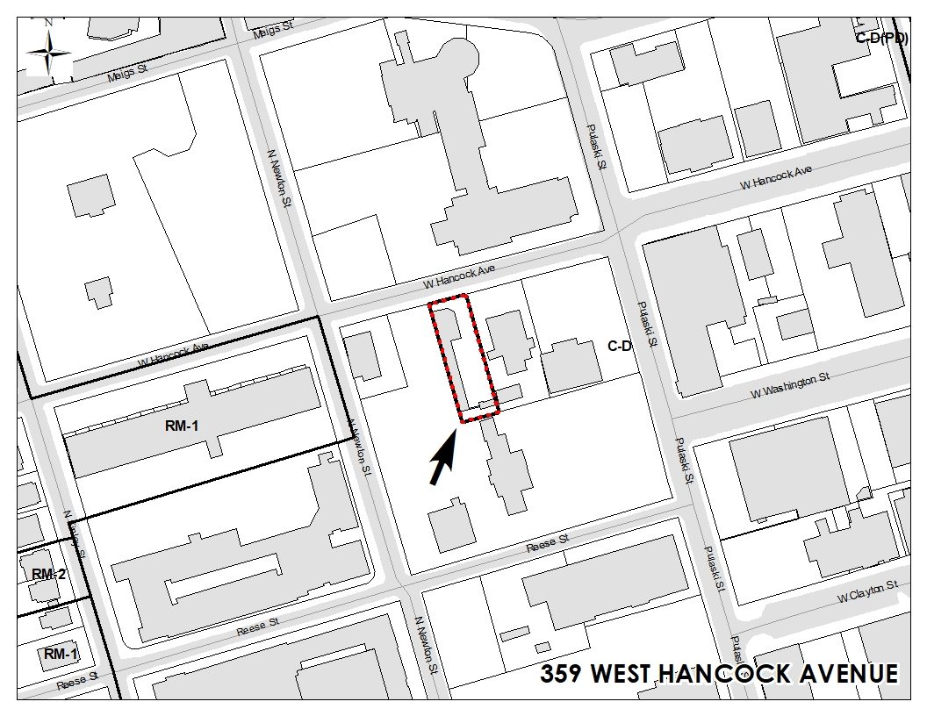

Athens-Clarke County Planning Department
Request for Variance to be heard by the Athens-Clarke County Hearings Board

June 11, 2025
VAR-2025-05-0898
Petitioner | Lucas Federico
Location | 346 Atlanta Avenue
Project Number | VAR-2025-05-0898
Tax Parcel Number | 163C1 F005
Zoning | RS-8 (Single-Family Residential)
Current Use | Residential
Proposed Use | Residential

A. Variance to increase maximum size of an accessory structure from 800 square feet to 1200 square feet (Sec. 9-15-12-E).

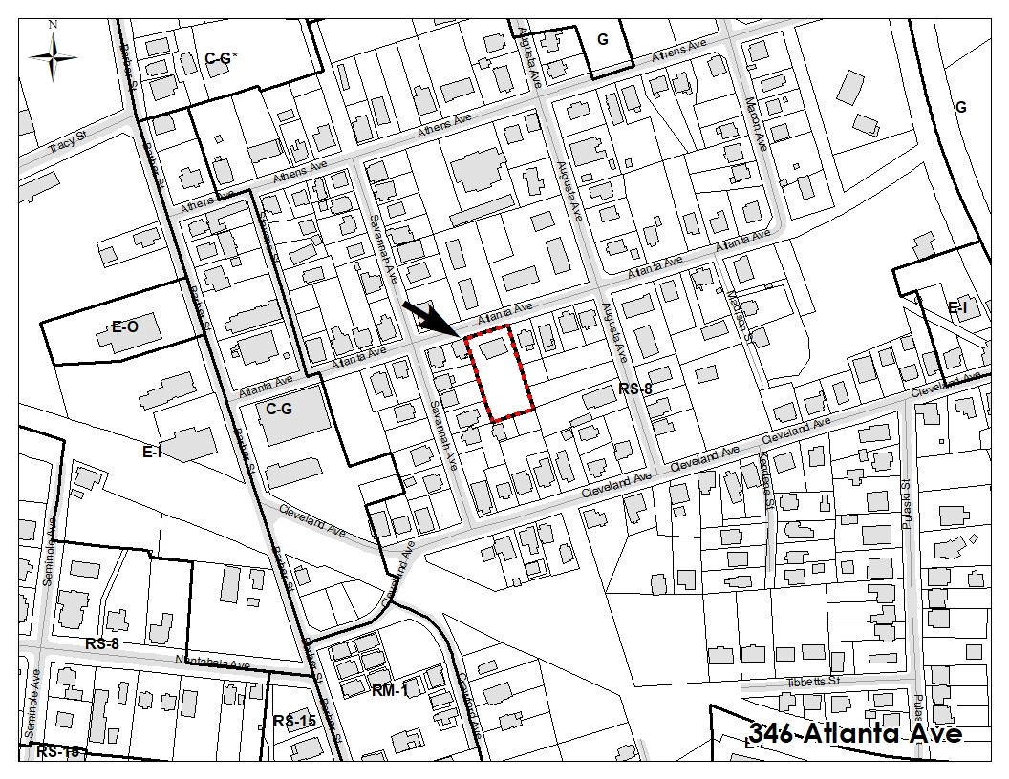

Athens-Clarke County Planning Department
Request for Variance to be heard by the Athens-Clarke County Hearings Board

June 11, 2025
VAR-2025-05-0900
Petitioner | Seed South Tallassee, LLC.
Agent | Jerry Wood
Location | 655 Tallassee Rd
Project Number | VAR-2025-05-0900
Zoning | RS-15 (Single-Family Residential)
Tax Parcel Number(s) | 064 044
Present Use | Undeveloped
Proposed Use | Residential

A. Variance to increase the maximum disturbed area from 25 acres to 32.9 acres (Sec. 9-26-A.6.d(2)).
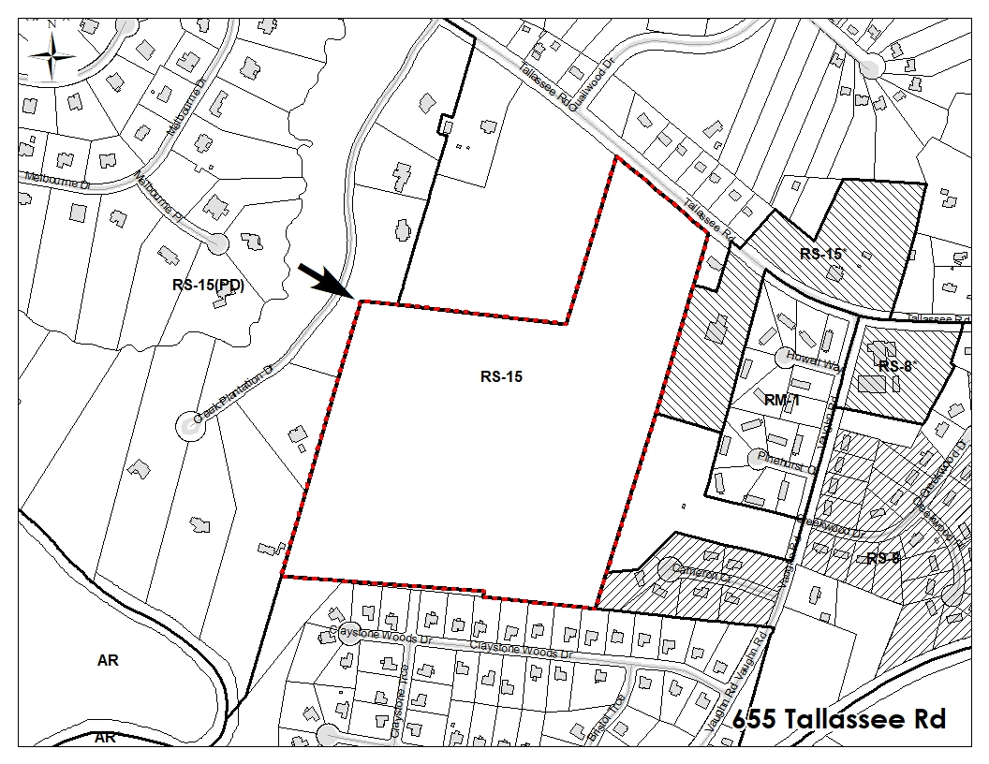

Athens-Clarke County Planning Department
Request for Variance to be heard by the Athens-Clarke County Hearings Board

June 11, 2025
VAR-2025-05-0901
Petitioner | Karen Payne
Agent | Lane Seabolt
Location | 850 Boulevard
Project Number | VAR-2025-05-0901
Zoning | RS-15 (Single-Family Residential)
Tax Parcel Number(s) | 114D1 G010
Present Use | Residential
Proposed Use | Residential
A. Variance to allow a reduced setback for an accessory structure that is less than 50' from any road (Sec. 9-15-12-D).
B. Variance to increase the height of an accessory structure from 12 feet to 14 feet (Sec. 9-15-12-D).