College Station Road Bicycle Improvement (from Research Drive to Barnett Shoals)

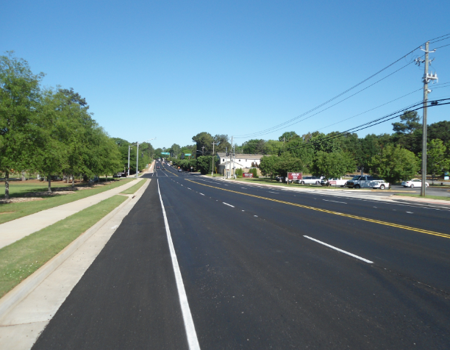
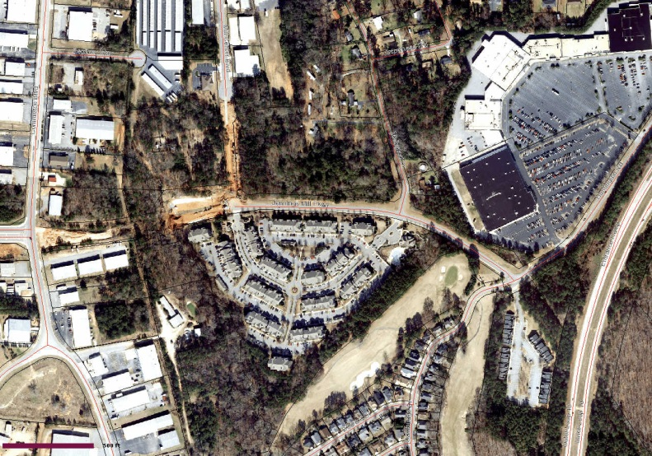
Before After

Purpose:
In accordance with the Bicycle Master Plan, will complete bicycle lanes on both sides of the remaining section of College Station Road between Research Drive and Barnett Shoals Road.

Project Details:
The construction will include widening of the road to accommodate the five-foot wide bicycle lanes on both sides and the addition of new five-foot wide sidewalks where none exist. The widening will be limited to one side of College Station Road as much as possible to minimize impacts to existing utilities, roadway features, and property acquisition needs.

Phase | Agenda Date | Funding Source | Budget | Actual | Begin Date | End Date
Concept | Oct. 2013 | SPLOST 2011 |  |  | Oct. 2013 | March 2014
PE Design | July 2014 | SPLOST 2011 | $102,333 | $289,141 | July 2014 | Aug. 2016
ROW |  | SPLOST 2011 |  | $44,722 | Jan. 2015 | June 2016
Construction | Dec. 2015 | SPLOST 2011 | $2,751,670 | $2,942,044 | Jan. 2016 | July 2017

Concept: Arcadis David Clark
Design: Arcadis David Clark
Construction: Contractor David Ayers
Notes: Additional info related to the budget funding, timing or elements of project to provide further info
regarding Project Details or to explain an element of the project.
Project: 6243

