Watershed Management Plan

Tanyard Creek

The Unified Government of Athens-Clarke County

July 22, 2011

Department of Transportation and Public Works
120 West Dougherty Street
Athens, GA 30603

Contents

Chapter 1 Introduction
1.1 Purpose of Tanyard Creek Watershed Management Plan
1.2 Outline of Tanyard WMP
1.3 Snapshot of Tanyard Creek
Chapter 2 Methodology
Chapter 3 Current Conditions in Tanyard Creek
3.1 Physical Stream Assessment
3.1.1 Stream Walk Assessment Method and Scores
3.1.2 Tanyard Creek Stream Bed, Banks, and Buffers
3.1.3 Potential Stressors Affecting Tanyard Creek’s Stream Assessment Scores
3.2 Biological Stream Assessment
3.2.1 How Macroinvertebrates Are Indicators of Stream Health
3.2.2 Macroinvertebrate Collection and Scoring Method
3.2.3 Biological Score Results for Tanyard Creek
3.2.4 Potential Stressors Affecting Tanyard Creek’s Biological Score
3.2.5 How Biofilms Indicate Stream Health
3.2.6 Biofilm Analysis Methods
3.2.7 Biofilm Analysis Results
3.2.8 Historical Impacts on Aquatic Habitat and Stream Health
3.3 Water Quality Data
3.3.1 Why Sample?
3.3.2 Three Water Quality Sampling Methods
3.3.3 Water Quality Data for Tanyard Creek
3.3.4 Potential Stressors Affecting Tanyard Creek’s Water Quality
3.4 Conceptual Model of Tanyard Creek Conditions and Concerns
Chapter 4 Tanyard Creek Watershed Management Plan
4.1 Summary of Management Needs
4.2 Tanyard Creek Best Management Practices to Achieve Goals and Objectives
4.2.1 Centralized BMPs
4.2.2 Distributed BMPs
4.2.3 Stream Channel Restoration
4.2.4 Sewer Line Maintenance/Replacement
4.2.5 Streambank/Riparian Area
4.2.6 Citizen Education
4.2.7 Other BMPs
4.3 Evaluation and Location of BMP Priority Areas
4.4 Estimated Load Reductions of Best Management Practices
4.4.1 Characteristics of the Management Plan Strategy
4.4.2 Modeling and Assessment Approach
4.4.3 Modeling Results
4.5 Implementation Cost and Schedule
4.6 Evaluation Methods for Measuring Success
4.6.1 Quantitative Evaluation Techniques
4.6.2 Qualitative Evaluation Techniques
Appendix of Charts and Data

Chapter 1: Introduction

1.1 Purpose of the Tanyard Creek Watershed Management Plan

The Tanyard Creek Watershed Management Plan (WMP) is part of an effort undertaken by Athens-Clarke County Stormwater to address stream health throughout the county. The primary purpose of the Tanyard Creek Watershed Management Plan is to guide County staff, elected officials, community organizations, and the citizenry to protect and where needed restore the beauty and function of the watershed. The plan is intended to be a practical tool with specific recommendations on practices to improve and sustain a healthy, productive environment. Tanyard Creek is listed on the federal 303(d) list of impaired streams due to fecal coliform contamination and thus some of the management strategies in this plan will seek to address this concern and ultimately allow for removal of the stream from the 303(d) list.

1.2 Outline of Tanyard Creek WMP

The plan consists of the following pieces:

- Chapter 1 provides an introduction including the purpose and an outline of the Tanyard Creek WMP. It also provides a brief description of the watershed including its physical boundaries and landmarks found within the drainage area.
- Chapter 2 describes briefly the methodology that was used in assessing the watershed’s health.
- Chapter 3 presents the current conditions of Tanyard Creek including its physical, biological, and water quality conditions. It describes the potential stressors effecting Tanyard Creek.
- Chapter 4 explains the watershed management plan, a summary of the management needs, the BMPs to be used, estimated load reductions, an implementation schedule and cost assessment, and evaluation methods.
- Appendix provides the stream assessment data including physical, biological, and water quality data.
1.3 Snapshot of Tanyard Creek

The Tanyard Creek Drainage Basin (TADB), as shown in Figure 1.3.1, lies almost in the direct center of the County. It has a land area of approximately 1 square mile. Its headwaters are underground near the intersection of West Hancock Avenue and Church Street. The stream itself is largely piped, but it does daylight near the intersection of South Newton and Waddell Streets, before running underneath Baxter and South Lumpkin Streets. Most of the land in this drainage basin is used for commercial areas or the University of Georgia; also present are residential areas and transportation corridors. An important note about Tanyard Creek is that it also runs underneath Sanford Stadium, where the University of Georgia Bulldogs play football. Sanford Stadium can house over 90,000 people on a football Saturday, when campus is flush with over 100,000 people and all the potential pollution that comes with them.
All of the land in this area drains into the North Oconee River before eventually flowing into the Oconee River, which is a source of our local drinking water.

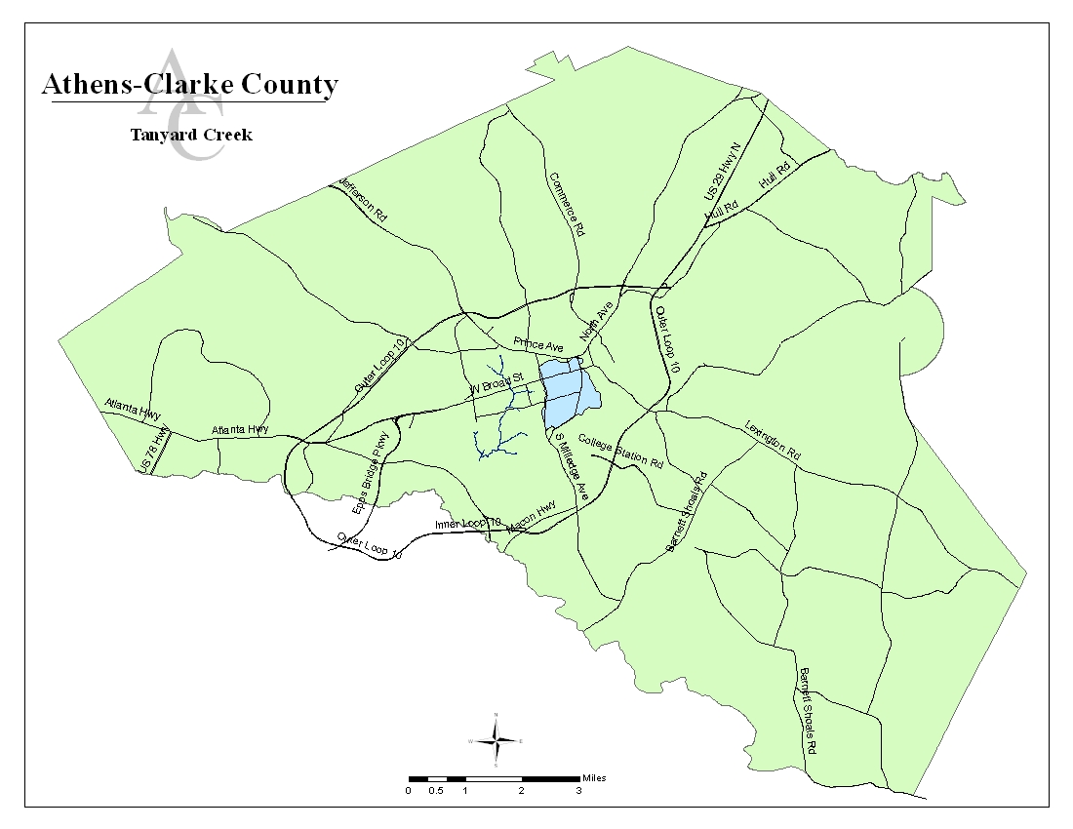

Figure 1.3.1: Location of Tanyard Creek Drainage Basin in Athens-Clarke County

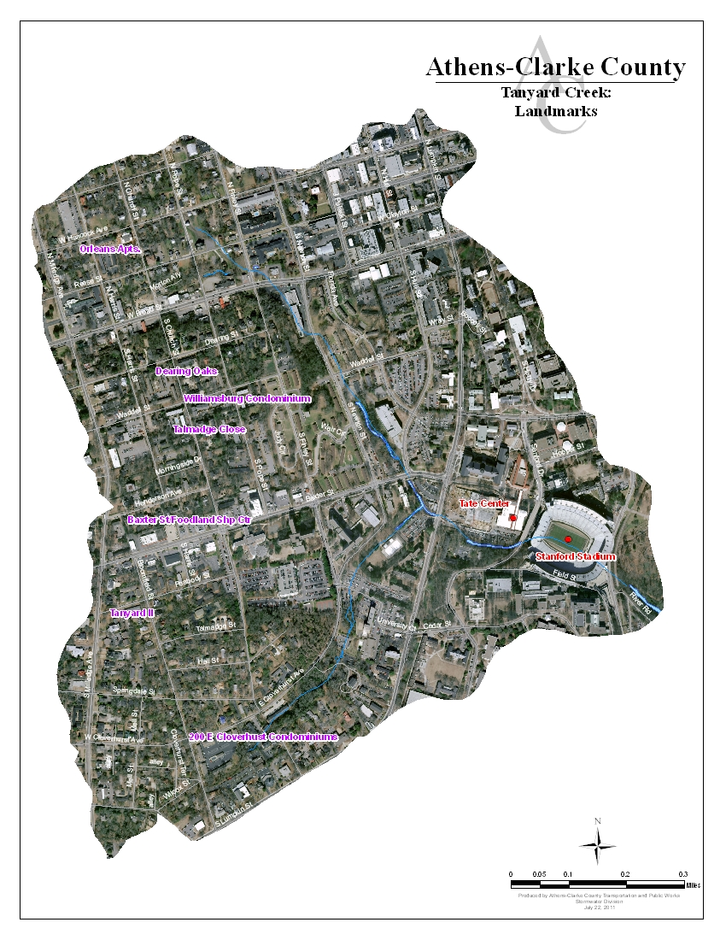
Figure 1.3.3: Landmarks in Tanyard Creek Drainage Basin
Chapter 2: Methodology

We used three different methods of data collection to gain a full picture of the current health of Tanyard Creek. Each data collection method will be described in detail, as will our findings and how they compare to “healthy” water quality standards. First, we conducted a stream assessment. ACC Stormwater staff walked Tanyard Creek and its larger tributaries to take physical measurements of the stream bank, stream bed, and stream buffer (Figure 2.1), as well as qualitative measurements of other factors like surrounding land use and stream crossings. A second assessment method was to determine current biological status of the creek. UGA collected macroinvertebrates (tiny aquatic bugs) living in the stream. The type and quantity of macroinvertebrates found is very useful for determining how healthy the stream is through the organisms’ adaptability and survival capabilities. Some macroinvertebrates are more sensitive to pollution and stream bed silting than others, so by assessing what species are present, we can determine whether the stream’s ability to support life has been impacted. The third assessment method was to collect water quality data. We have collected both periodic and long-term water quality data, and we use data collected by GAEPD and local watershed groups that have been sampling and recording water quality data for many years.

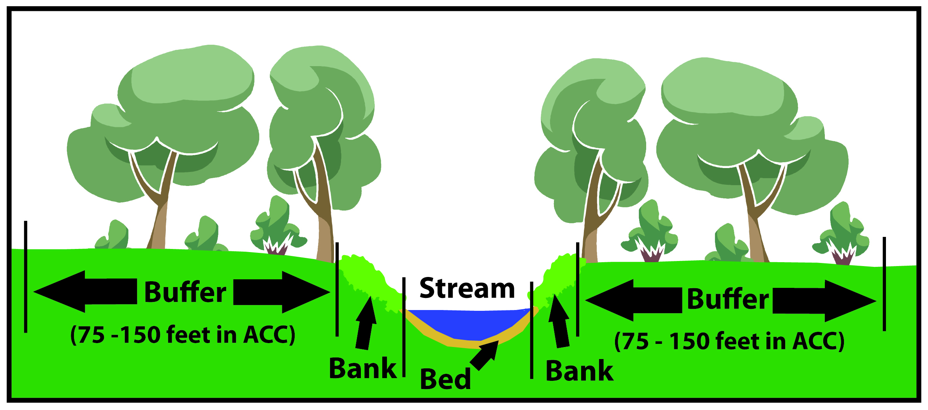
Figure 2.1: Cross Section of a Stream

The data from all of these methods is combined to give us a picture of how healthy Tanyard Creek is at this moment in time, and it guides us towards discovering potential watershed “stressors,” which are sources of pollution and impairment. Let’s look at the data collected through each method and consider what could be stressing the health of Tanyard Creek.

Chapter 3: Current Conditions in Tanyard Creek

  - Physical Stream Assessment
3.1.1 Stream Walk Assessment Method and Scores

Stream walks were conducted in the Tanyard Creek watershed in February of 2010. The stream was divided into sections, and each section is called a “reach.” ACC Stormwater Staff physically walked each reach and conducted an inventory of stream bed, stream bank, and stream buffer condition. (A stream buffer is the vegetated strip of land along either side of the stream.) Figure 3.1.1.1 shows the reaches surveyed in TADB and the following photos highlight some of the areas in TADB (Photos 3.1.1.1 – 3.1.1.4). Reaches are named alphabetically on the main stem of Tanyard Creek and the tributaries are named numerically.
Figure 3.1.1.1: Tanyard Creek Stream Reaches
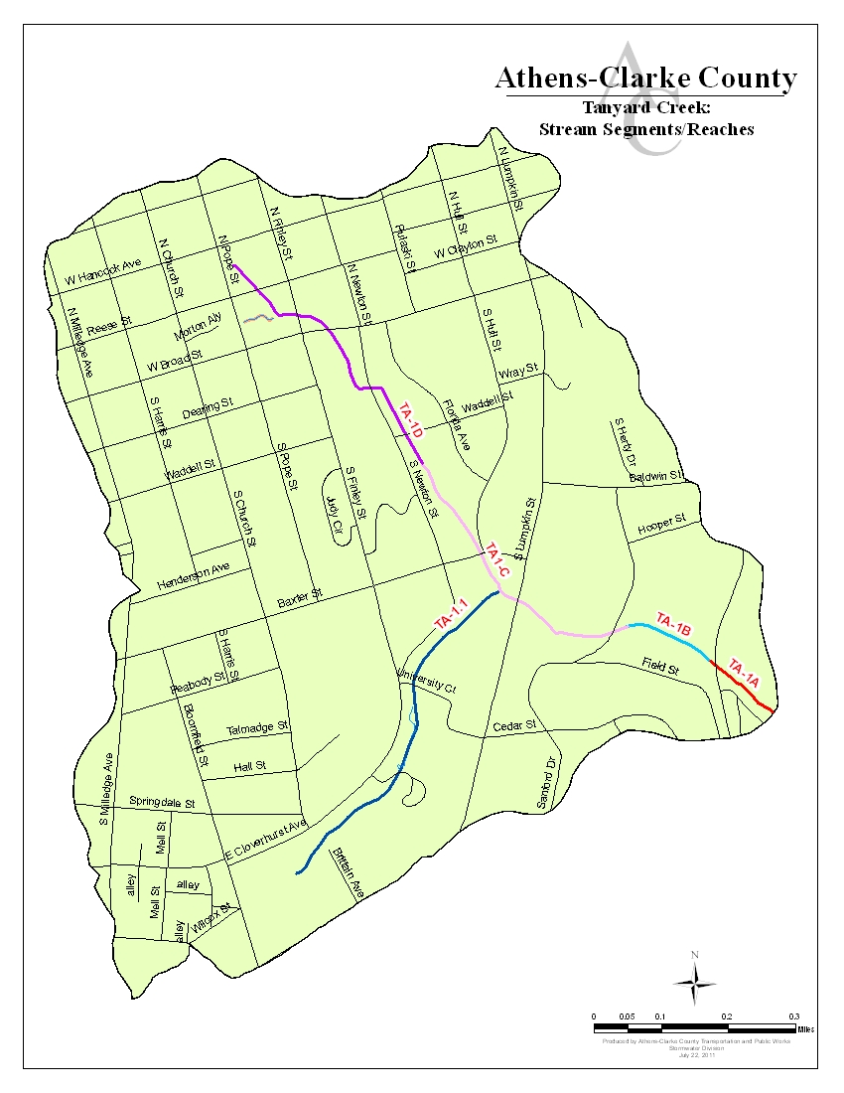
Photo 3.1.1.1: Stream Assessment of Tanyard Creek – Taking Bed, Bank, and Buffer Measurements
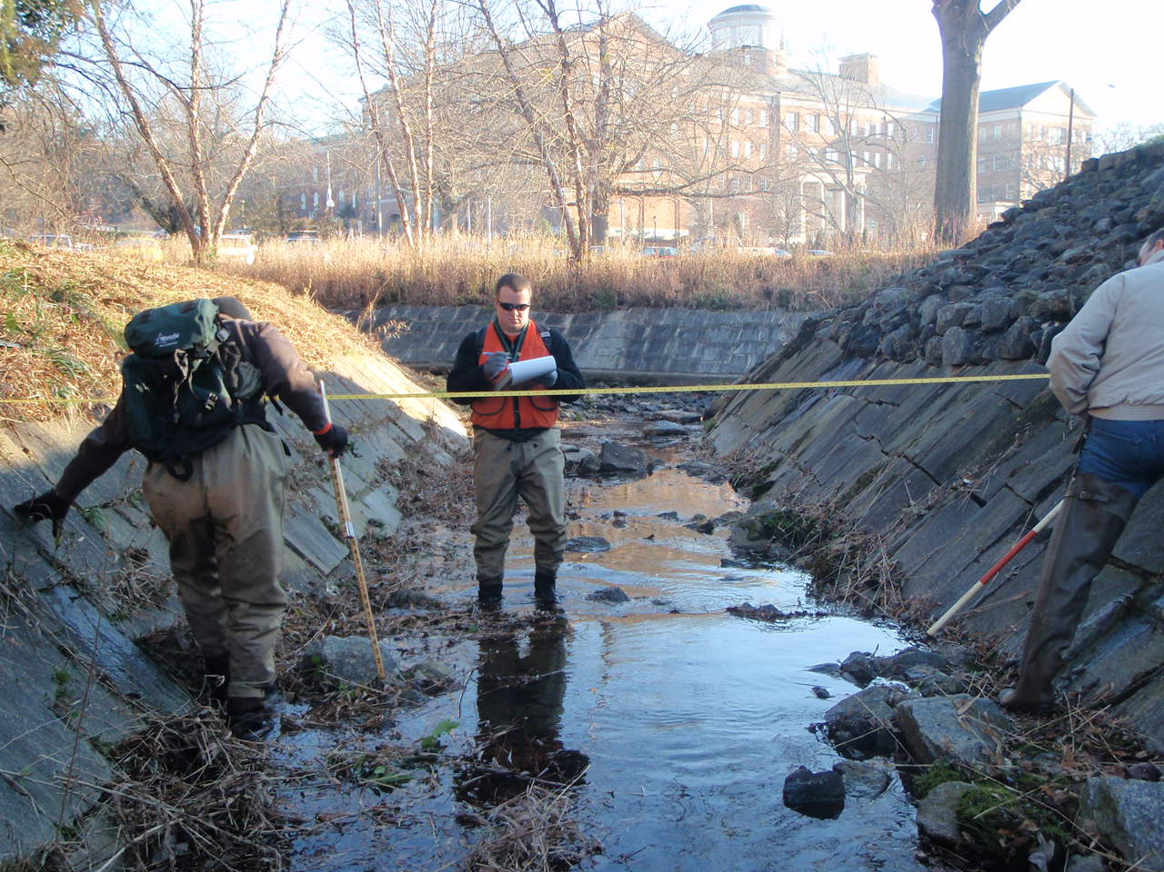
Near the confluence of Tanyard and Tributary TA1.1

Photo 3.1.1.2: Stream Assessment of Tanyard Creek – Armored Crossing on UGA’s Campus
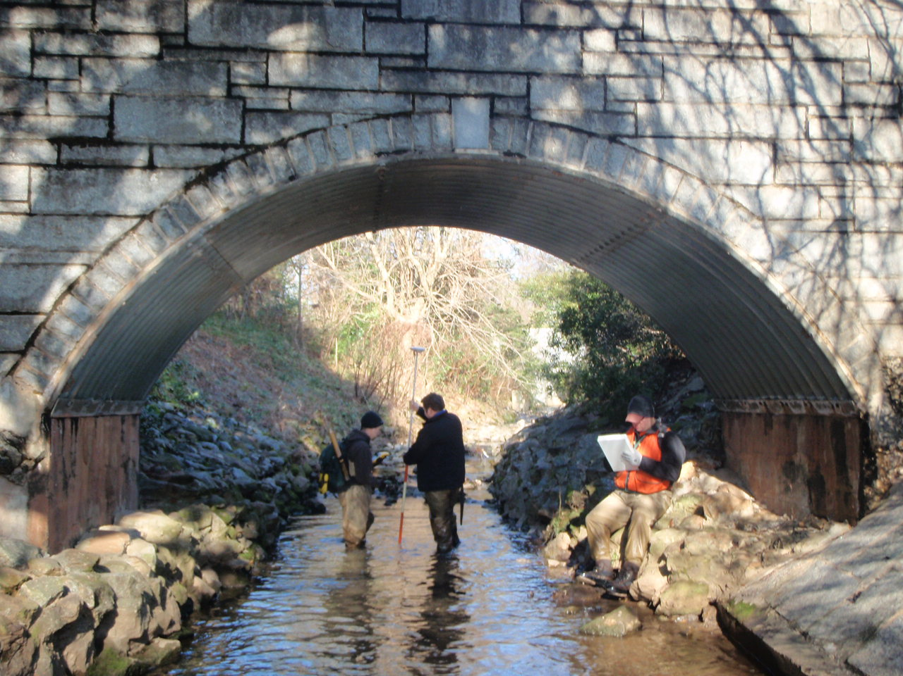
Pedestrian Bridge from Legion Field Parking Lot

Photo 3.1.1.3: Stream Assessment of Tanyard Creek – Downstream of Sanford Stadium
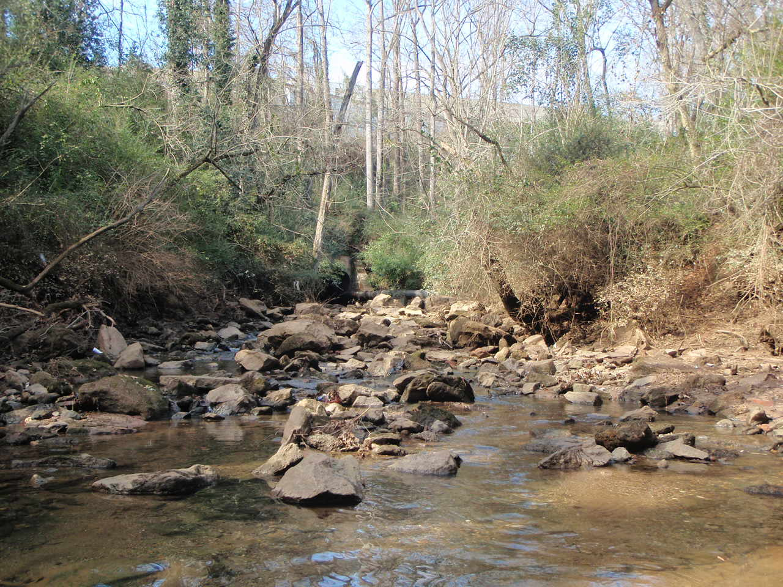
Cobble, Trash in Bed in Reach Ta1a (Downstream of Sanford Stadium)

Photo 3.1.1.4: Stream Assessment of Tanyard Creek – Eroded Bends on Ta1.1
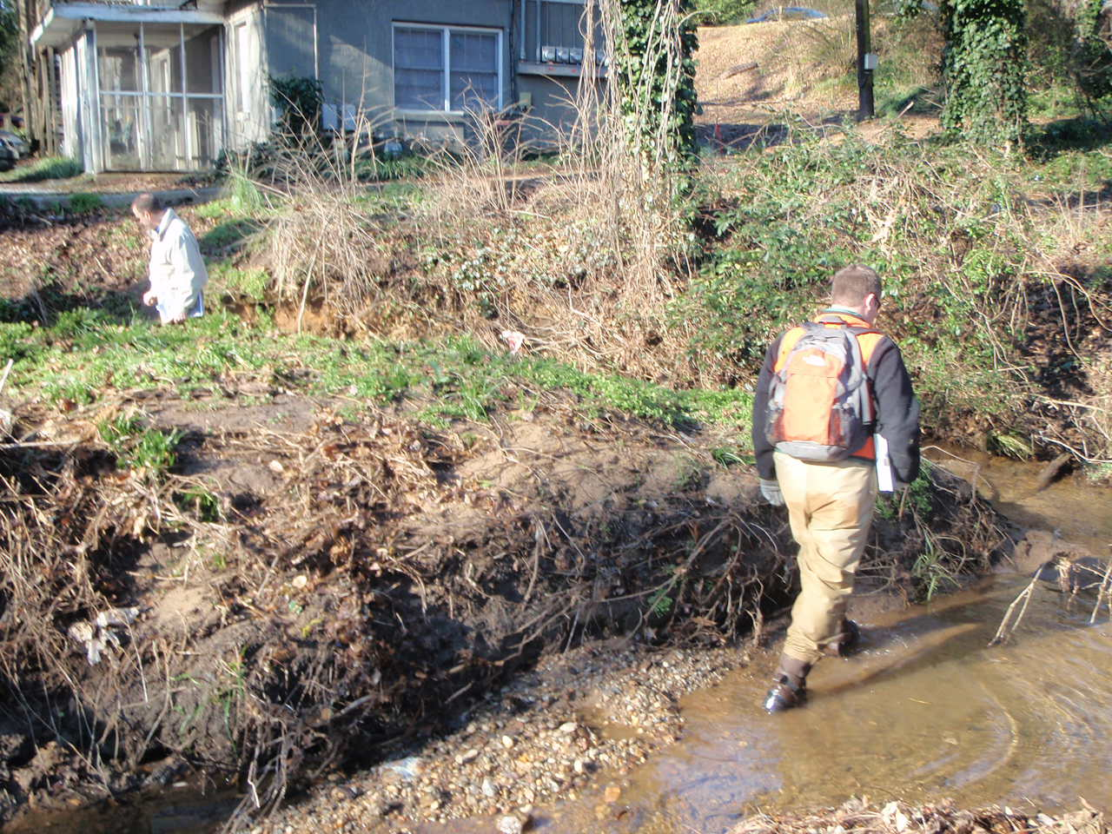
Bends eroded due to urbanization, as evidenced by the house in the buffer.

Each reach was rated by the average of the data collected there. The in-stream habitat, vegetated buffer width, bank erosion, and floodplain connection were also evaluated in each reach and assigned a score. Each category could receive a maximum of 20 points, with vegetated buffer width and bank erosion scores allowed 10 points for each bank. A reach’s maximum score is 80. The benchmark set for a “healthy” rating is a score of 63 or above. A score of 63 or greater suggests that a stream has optimal bed, bank, and buffer conditions for a healthy functional stream ecosystem compliant with state and federal regulation. The range for the stream assessment scores is: (Poor: 0-23, Marginal: 24-40, Sub-Optimal: 41-63, Optimal: 64 – 80). Table 3.1.1.1 shows the results of the stream survey, while Figure 3.1.1.2 shows the reach scores and their locations. The Tanyard Creek Watershed’s overall stream condition is rated as “Poor,” with an average score of 21 points. Driving this poor score is impairment of the bed, banks, and buffer of the stream. Figure 3.1.1.3 shows the reach scores and their locations.

Table 3.1.1.1: Reach Scores of Tanyard Creek
Reach | In-Stream Habitat Score | Vegetated Buffer Width Scores |  | Bank Erosion Score |  | Floodplain Connection | Total Reach Score | Percent Score
 |  | Left Bank | Right Bank | Left Bank | Right Bank
1a | 6 | 1 | 2 | 4 | 3 | 1 | 17 | 21.3%
1b | Underneath Sanford Stadium – Not Walked
1c | 12 | 0 | 0 | 2 | 2 | 0 | 16 | 20.0%
1d | Piped – Not Walked
1.1 | 8 | 3 | 1 | 3 | 3 | 11 | 29 | 36.3%
Averages | 8.7 | 1.3 | 1.0 | 3.0 | 2.7 | 4.0 | 21 | 25.8%
Percent | 43.3% | 13.3% | 10.0% | 30.0% | 26.7% | 20.0% | 25.8%
Table 3.1.1.1 shows the breakdown of the reach assessment scores and the combined scores, as well as the average score of 21

Figure 3.1.1.2 Reach Scores of Tanyard Creek

The average reach score in TADB was 21, with reach Trib 1.1 scoring the highest (29) and reach Ta1c scoring the lowest (16).

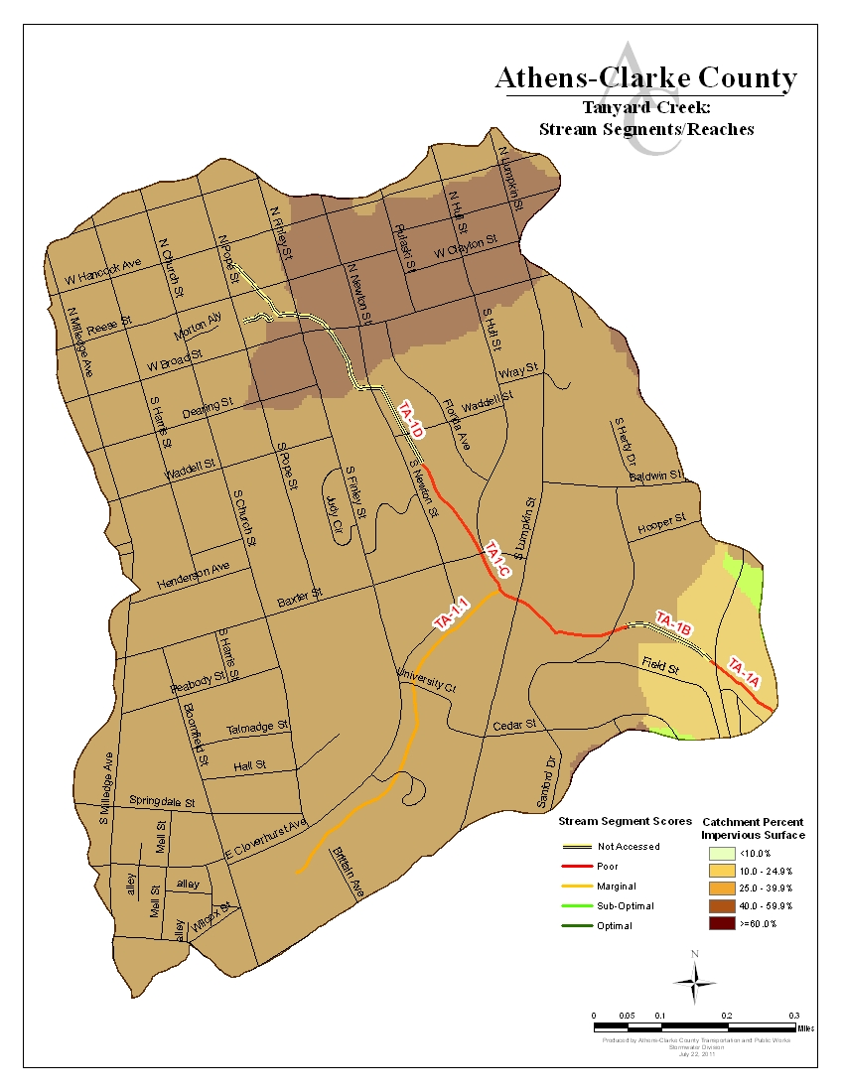
Figure 3.1.1.3: Stream Assessment Scores and Their Reach Locations

3.1.2 Tanyard Creek Bed, Banks, and Buffers

Tanyard Creek is a highly urbanized stream that has been greatly affected by the development around it. This development has had a significant impact on the bed, banks, and buffers of the stream. It includes two reaches that were not able to be walked and assessed: Reach TA-1b is culverted underneath Sanford Stadium, and TA-1d is piped underneath roads and surface lots all the way to the stream’s headwaters. The headwaters of the stream appear to be weep holes in a brick box underneath a catch basin on Church Street.

The bed of Tanyard Creek is highly variable, but this is most likely due to human influence and attempts to stabilize it using riprap and placed stones. Reach TA-1a is has a significant backwater effect for approximately the first 250 feet upstream of the confluence with the river, lining the bed with sand. Further upstream in Ta-1a there is increasing cobble to boulders to bedrock before the culvert underneath East Campus Road and Sanford Stadium. The bed of reach TA-1c is made up mostly of riprap and stone with gravel and some sand. In this reach the gravel appears to be more of manmade gravel and asphalt, indicating likely runoff from the numerous roads and parking lots adjacent to the stream. The bed in Tributary TA-1.1 is made up of mostly sand and is highly aggraded. It too has some areas containing riprap and concrete.

Overall, erosion was not a significant issue in Tanyard Creek, but it was present. There is a considerable amount of armoring on the banks of the stream suggesting that erosion was at one time an issue. There were spots along the stream where major erosion had occurred and could be a threat to infrastructure, particularly in Reach TA-1c. One interesting thing to note is the lack of significant amounts of sediment throughout the main channel, despite both current and past erosion. This is likely due to the amount of development around Tanyard Creek.

All the development in the TADB has created a large amount of impervious area. Impervious areas are spaces in which water cannot penetrate to the soil such as buildings, roads and parking lots. Rainwater that falls on these surfaces cannot soak into the soil but instead collects into stormwater runoff when it rains. The larger the impervious area the higher speeds at which stormwater runoff enter streams and subsequently the greater impact a rain fall event will have. The subwatersheds in TADB range in impervious surface area from 10 to 20 percent to greater than 60 percent. Approximately 90 percent of TADB has 40 percent imperviousness or greater. Percent impervious is calculated by dividing the total impervious surface of a catchment by the total catchment area. Increase in impervious area can decrease water quality and habitat. Increased impervious surface area leads to increased flow, which is a direct cause of scouring of banks and buffers, but also moves sediment through the system much faster.

Of particular concern in the Tanyard Creek watershed are the stream buffers. A stream buffer is the strip of stream bank closest to a stream that should contain trees, shrubs, and other plants. In Athens, the buffer is protected by state law for 25 feet from the stream, and local ordinance protects the buffer for additional 50 feet for a total protected buffer of 75 feet. This means that it is unlawful to remove trees and other vegetation for 75 feet to either side of the stream. The plants in this protected strip of land surrounding streams provide stream shading for cooler water. The plants also protect stream banks from erosion, filter pollutants like oil and sediment out of runoff entering the stream, and provide habitat for fish and other wildlife. An intact buffer stabilizes the stream banks while providing a multitude of benefits for plant and animals that live in and around the stream. Development and construction has occurred in Athens for over a century prior to the 75 foot buffer ordinance, and many stream buffers were removed to make way for agriculture, residential homes, commercials areas, and transportation corridors during his period. Also contributing to buffer removal is the fact that many current residents are unaware of the importance of a buffer and remove it for aesthetic landscaping purposes. As previously mentioned, Tanyard Creek is highly urbanized and development has encroached almost the entire buffer. In fact, no portion of the stream has an intact 75 foot buffer; only small portions have much more than 10 feet (the upper portion of TA-1.1). Tanyard Creek lies largely on the University of Georgia’s campus and the buffers are largely encroached by parking lots, classroom buildings and other impervious surfaces that provide no treatment of runoff and often allow for easy introduction of trash and other pollutants into the stream.

3.1.3 Potential Stressors Effecting Tanyard Creek’s Stream Assessment Scores

Now that we’ve collected data and compiled what we’ve seen going on in Tanyard Creek, we look at the data to try and identify what could be contributing to both the good and bad conditions found in the stream. It is important to remember that we’re working with just one data set, which is just one glimpse of stream conditions at one point in time. It can be compared to a doctor trying to diagnose a chronic condition in a patient by only seeing him once; the patient may have been having a good day or a bad day, and we won’t know what’s really going on until we collect repeated data in the future. This first round of findings does still give us enough information to make some general conclusions about what is impacting Tanyard Creek and what is not. The greatest piece of evidence we found is the urbanization and human influence on Tanyard Creek.

While current erosion was not a significant problem in TADB, the amount of armoring on the banks and beds indicate past issues with erosion, and thus the lower scores, as does the altered hydrology that is caused by increased runoff entering the stream at increased velocities. Remember that all rain water that cannot soak into the ground is routed directly into the nearest stream via the stormwater system. The more water there is entering the stream and the faster it is moving, the more the stream banks and bed are scoured away. Erosion increases, and once the stream flow slows down this eroded sediment is dropped onto the stream bed where it impacts the stream’s ability to sustain wildlife. In Tanyard Creek this only occurs near the confluence with the river, yet there are still few to no habitable areas for macroinvertebrates. This increased runoff flow and volume is caused by an increase in the amount of impervious surface in a drainage basin. When there are more roads, parking lots, and buildings with impervious surfaces, less rain water can soak naturally into the ground. More runoff must be directed into the stormwater system to prevent flooding. When it rains, this increased water volume doesn’t gradually flow into our rivers and streams unless stormwater controls are in place to slow the runoff down. So, a heavy rain in an area with a high percentage of impervious surfaces and insufficient stormwater controls means that a lot of water is traveling very fast into a nearby stream. Fifty-five percent (55%) of the Tanyard watershed is covered in impervious area with most drainage areas between 40 and 60 percent impervious area (see Figure 4.4). There is a correlation between increased residential, commercial, and roadway development with erosion, incision, and aggradation in streams.
The stream buffer along Tanyard Creek scored an average of 11.5% out of a scale of 100%, putting it well in the “Poor” range. The reason it scored poorly is because the buffer is narrow or non-existent in most reaches. Buffer loss is almost entirely a man-made problem. As mentioned before, the buffer was removed by development done prior to buffer protection ordinances. In residential areas stream buffers are sometimes removed by property owners during landscaping. Some bank support (such as riprap and various types of retaining walls) has been added along private property in the residential areas of the watershed, and along portions of University property as well. When applied properly, this type of bank stabilization can be very effective. Unfortunately, it appears as though some of these measures were taken haphazardly in the past and much of the riprap, etc has just ended up in the bed of the stream. Also, many residents dump lawn clippings and other yard debris into the stream or the stream buffer and this does not help in stabilization. Yard debris can have multiple affects on the stream, including using up oxygen which is needed by fish and other stream inhabitants. The high dissolved oxygen levels collected do not indicate this as being a concern in TADB. However, yard debris can carry fertilizers or pesticides from yards directly to the stream.

Also noted during the streamwalks were a number sewer lines with potential for breaks or future problems. This does not include the unwalkable reaches of the stream (Ta-1b and Ta-1d) where the state of the sewer lines could not be assessed.

3.2 Biological Stream Assessment

3.2.1 How Macroinvertebrates Are Indicators of Stream Health

As mentioned earlier, macroinvertebrates are small bugs that can be seen with the human eye that live in the beds of streams. Since different species of macroinvertebrates are more sensitive to pollution and other impairments than others, the number and diversity of macroinvertebrates that are found in a stream can tell us a lot about water quality and stream health.

Photo 3.2.1.1: Macroinvertebrates

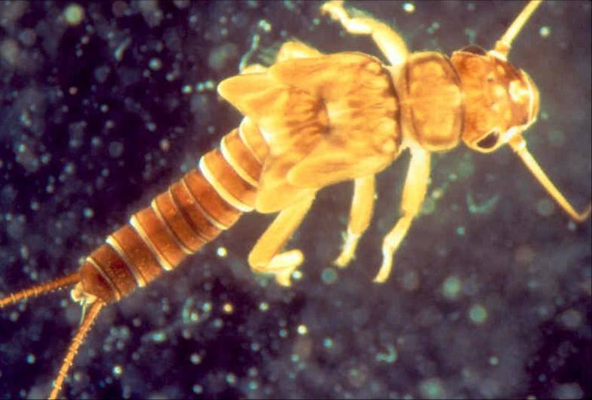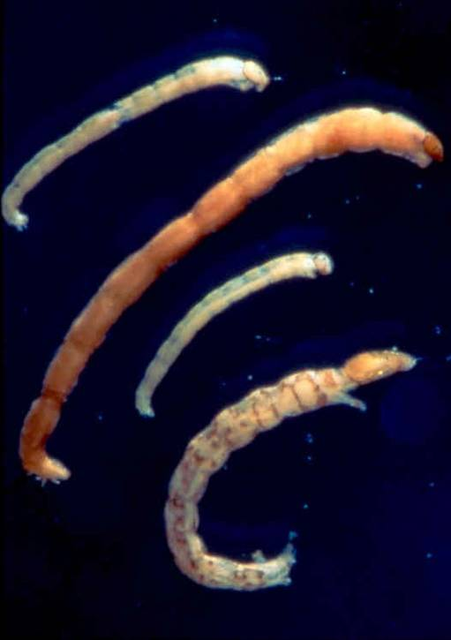

Photo 3.2.1.2: Macroinvertebrate Sampling

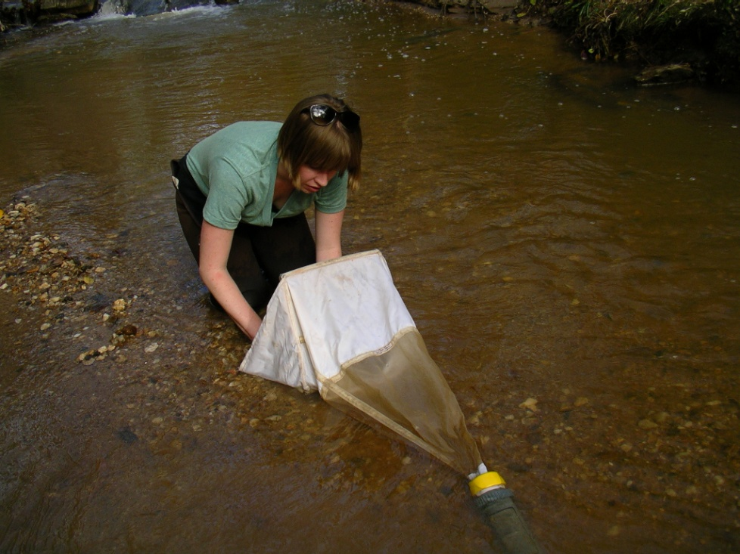

3.2.2 Macroinvertebrate Collection and Scoring Methods

Macroinvertebrate samples from Tanyard Creek were collected and evaluated by the University Of Georgia School Of Ecology in 2011. These samples were collected at two sites along Tanyard Creek (TAN1 and TAN2), as shown in Figure 3.3.2.1. The results from the sampling sites were scored using two methods. The Save Our Streams (SOS) Program of the Izaak Walton League of America, which is based on the presence or absence of “sensitive,” “somewhat sensitive,” and “tolerant” types of macroinvertebrates. Numerical scores were used to indicate water quality (excellent > 22, good = 17-21, fair = 11-16, poor < 11).

The Family-level Biotic Index (FBI) was used to evaluate the health of in-stream macroinvertebrates, which can then be correlated with the overall health of the stream itself. Macroinvertebrates were collected and then identified to the Family taxonomic level. Tolerance values were assigned to each taxon using the Family-level Biotic Index (Hilsenhoff 1988). This system assigns macroinvertebrate families a value of 0-10 based on their sensitivity to organic pollution (Excellent = 0.00 – 3.75; Very Good = 3.76 – 4.25; Good = 4.26–5.00; Fair = 5.01 – 5.75; Fairly poor = 5.76 – 6.50; Poor = 6.51 – 7.25; Very poor = 7.26 –10.00). Thus, the higher an FBI score, the more degraded a stream is.

3.2.3 Biological Score Results for Tanyard Creek

Table 3.2.3.1 below lists the biological score for each sampling site. Please refer to the map to see where each sampling site is located in the Tanyard Creek drainage basin.

Table 3.2.3.1 Macroinvertebrate Scores

Sample Site | FBI Score | Ranking | SOS Score | Ranking
TAN1 | 6.16 | Fairly Poor | 7 | Poor
TAN2 | 6.53 | Poor | 6 | Poor

FBI scores were “fairly poor” for TAN1 and “poor” for TAN2 while SOS scores were “poor” for both. This indicates a lack of macroinvertebrate presence throughout Tanyard Creek. This coincides with statements made previously about the inadequacy of Tanyard Creek’s in-stream habitat. Much of Tanyard Creek has been armored along the banks. Without adequate rock and cobble, as well as other natural habitat features, the proliferation of macroinvertebrates in the stream is significantly hindered.

TAN2
3.2.4 Potential Stressors Effecting Tanyard Creek’s Macroinvertebrate Scores

Impaired aquatic life in a stream is most often directly a result of degraded aquatic habitat. According to the data collected during the stream walks, the stream bed of Tanyard Creek was found to have some problems including sedimentation and aggradation. Many macroinvertebrate taxa live in riffle areas created by water moving over the stream bed material while others live in sandy pools. A wide range in bed sediment sizes provides a variety of habitat for different aquatic organisms that have different life history characteristics. Unfortunately, Tanyard Creek has very few of these riffles or sandy pools, instead the bed is mostly made up of manmade materials like concrete or riprap surrounded by sand and silt (Photo 3.2.4.1).

The stream buffers in all three reaches were severely reduced, scoring low in the ‘vegetated buffer’ category in the visual survey. (Table 3.1.1.1) Reduced vegetated buffers decrease shading resulting in increased stream temperatures. This may inhibit some macroinvertebrate taxa that are sensitive to high water temperatures. Benchmarks for temperature were set at 30°C (Table 3.3.3.1), and no temperatures exceeded this during the sampling period in Tanyard Creek. Thermal pollution is not a likely source of decreased macroinvertebrate scores. A reduction in vegetated buffers may, more importantly, decrease the amount of leaves and wood being delivered to the stream, important food and habitat sources for macroinvertebrates.

Other data points to high flows washing away leaf matter and other in-stream habitat for macroinvertebrates, making the stream much less hospitable. There is a high amount of impervious surface in the Tanyard Creek watershed, and this increases the amount of stormwater being delivered to the stream. In addition to scouring the stream, this increased stormflow may deliver harmful pollutants to the stream, decreasing water quality. Most macroinvertebrates are sensitive to water quality and several studies have shown a positive relationship between macroinvertebrate abundance and diversity and water quality (Komnoski et al. 2007, Roy et al. 2003). Sampling sites were selected for optimal conditions, so the poor scores are likely due to flow or pollution when sediment is not present at site. Conductivity, a measure of dissolved ions in the water and a good indicator of pollution from non-specific sources was high (>80 µS/cm; see Section III) at all three sampling sites on many sampling dates.

Photo 3.2.4.1 Example Stream Habitat in TADB

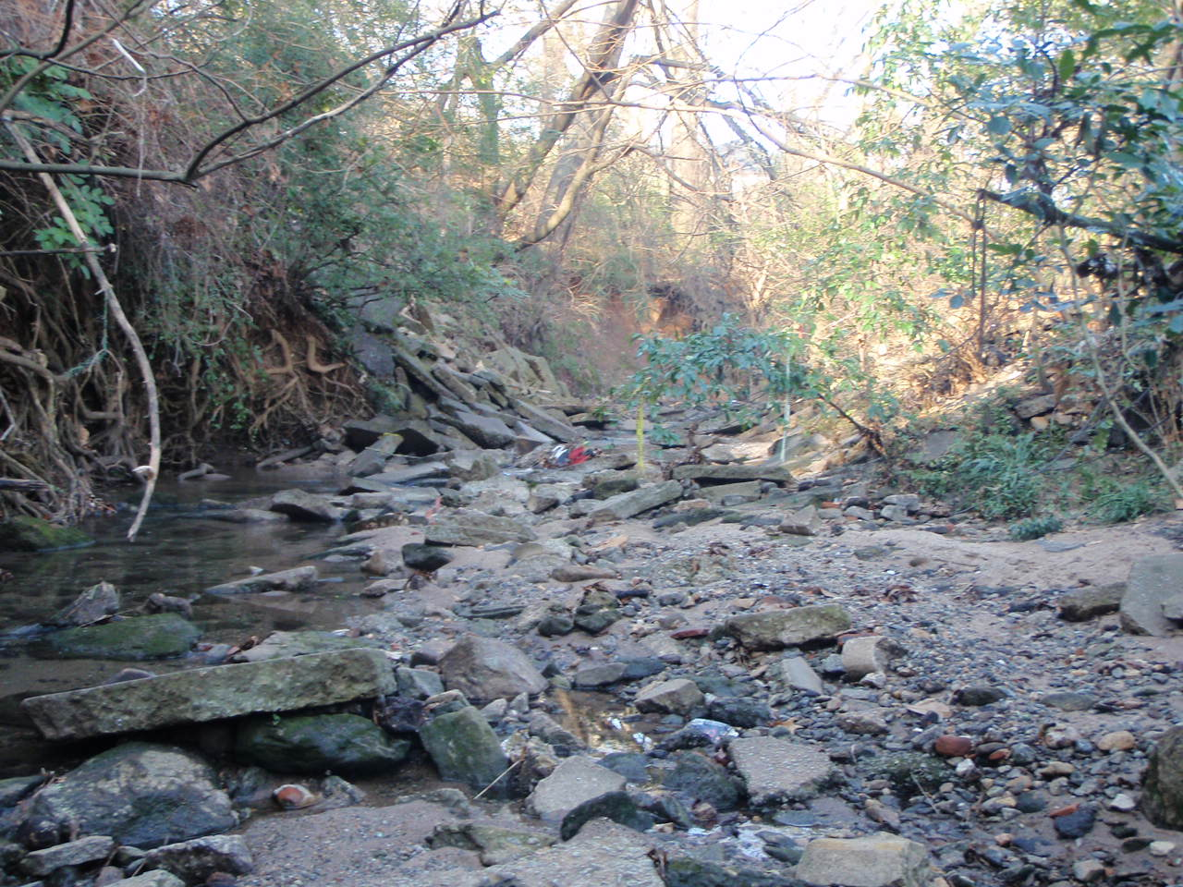

3.2.5 How Biofilms Can Indicate Stream Health

Biofilms are the algae, microorganisms and organic matter on the bottoms of streams. Analysis of biofilms can reveal a lot about stream condition. Increased biofilm mass could indicate high nutrient levels or increased light from a lack of riparian zone. Decreased biofilm mass could be the result of altered stream hydrology caused by high peak flows, erosion, and sedimentation in areas with impervious surfaces. Biofilm nutrient content may increase due to nutrients available in stream water and sources of nitrogen (N) can be traced by detecting isotopic signatures of N in biofilms. Biofilms are a food source for macroinvertebrates and fish as well as an important site for the uptake and storage of nutrients (Hoellein et al 2011).

3.2.6 Biofilm Analysis Methods

Biofilm samples from Tanyard Creek were collected and evaluated by the University Of Georgia School Of Ecology. Two sites (TAN1 and TAN2) were sampled in March 2012. Analysis looked at chlorophyll a and biofilm ash-free dry mass (AFDM) of both hard and soft substrates. Chlorophyll a is a measure of the algal component of biofilm mass while AFDM is the total mass of organic matter that makes up the biofilm. These values were measured for both hard (rocks) and soft (sand and organic material) substrates. Hard substrates are tightly attached and tend to have higher chlorophyll a levels, while soft substrates are more loosely bound and have higher AFDM (Sterling 2012). Low AFDM in soft substrates could indicate disturbed hydrology causing peak flows that scour away the soft substrates. Undesirable conditions in streams are likely best characterized by high algal biomass (high chlorophyll a) and loss of retention of organic material (low AFDM).

3.2.7 Biofilm Analysis Results

Table 3.2.7.1 Biofilm Scores

Sample Site | Chlorophyll a (mg/m²) |  | AFDM (g/m²)
 | Hard | Soft | Hard | Soft
TAN1 | 9.6 ±5.5 | 9.6 ±3.3 | 0.469 ±0.044 | 1.01 ±0.073
TAN2 | 7.0 ±0.9 | 3.8 ±1.4 | 0.785 ±0.183 | 3.27 ±0.802

Overall biofilm levels throughout Tanyard were extremely low. This fits with Tanyard Creek’s stream walk data that found significant amounts of stream bank and bed were armored, underground, or piped. Lack of stream bank vegetation and light means it is very difficult for biofilms to grow, even with the elevated nutrient levels in Tanyard. The expectation of higher levels of chlorophyll a in hard substrates and AFDM in soft substrates held for the most part except for elevated soft-substrate chlorophyll a at TAN1. AFDM readings reported in 2011 are significantly lower than those found in other ACC streams reported in 2013. This could be the result of different sampling or analysis methods. Understanding how nutrient concentrations stimulate algal growth in Tanyard Creek is important in managing the nutrient inputs, however further studies are needed to fully investigate the implications of these results.

3.2.8 Historical Impacts on Aquatic Habitat and Stream Health

Since excess sediment in the stream is the main cause of the stream bed aggradation, it’s important to determine where that extra sediment might be coming from. When considering the impacts of sediment, we need to look not only at what is happening in Tanyard Creek right now, but also at what went on in the Tanyard Creek basin regarding land use in the past. Review of historical aerial photography (Figures 3.2.4.1) shows that the Tanyard Creek basin area has been urbanized as far back as the 1930s, and was likely used for agriculture even before that. This is unsurprising due to its proximity to downtown and the University, which was founded in 1785. Sanford Stadium was built over the top of Tanyard Creek in 1929 and has grown significantly over the years, as has the University and its related impervious surfaces. Maps of this area from the 1950s and 1960s, Figures 3.4.2.2 and 3.4.2.3, show increased development and University growth. The effects of past agricultural use on the land often continue to impact local streams even 50 to 100 years after agricultural practices have been abandoned, manifesting as physical and chemical problems in streams (MacTammany, 2004). Refer to the following historical maps to see how land use has changed over time in Tanyard Creek.

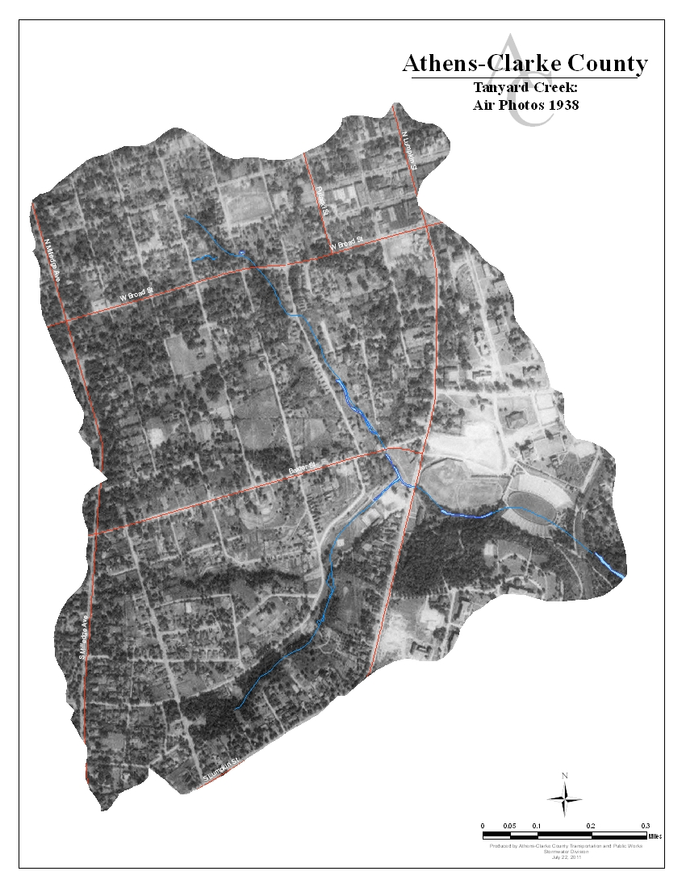

Figure 3.2.4.1 Tanyard Creek: 1938

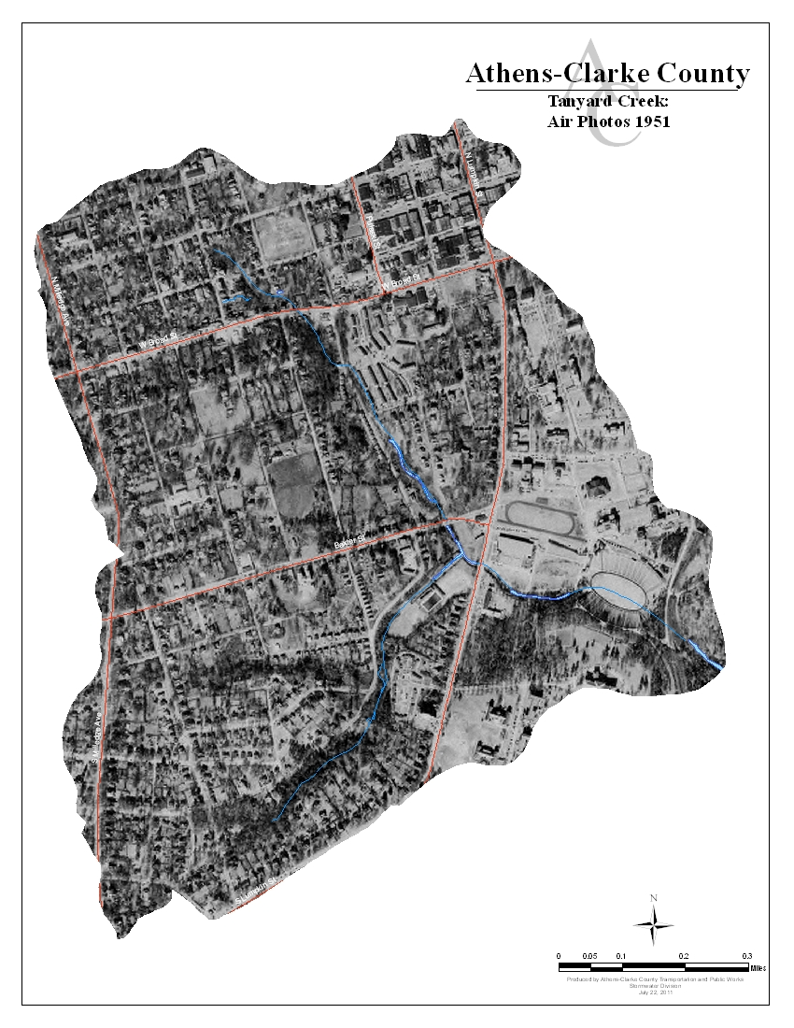

Figure 3.2.4.2 Tanyard Creek: 1951

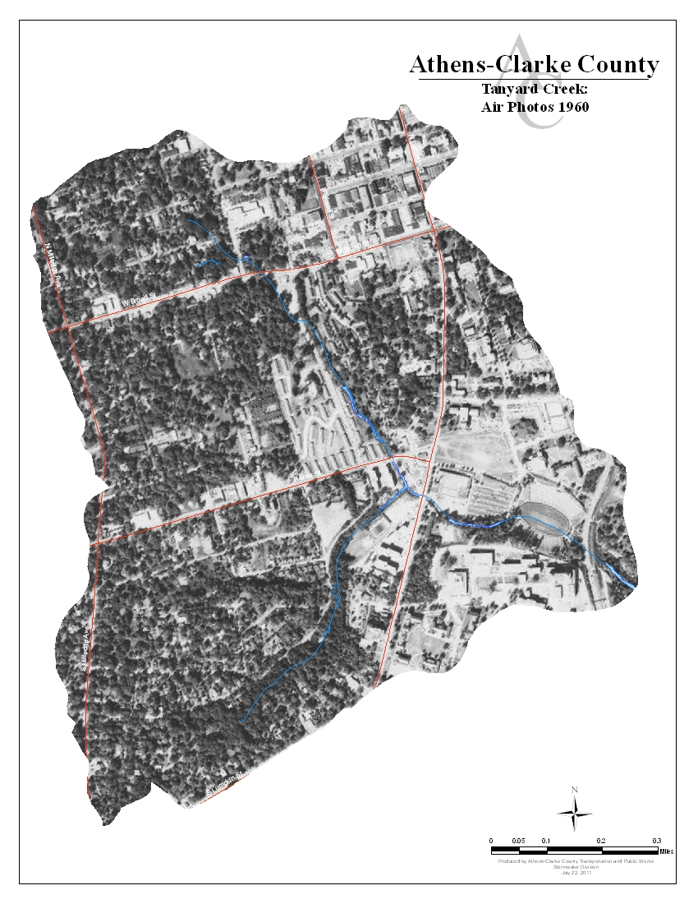
Figure 3.2.4.2 Tanyard Creek: 1960

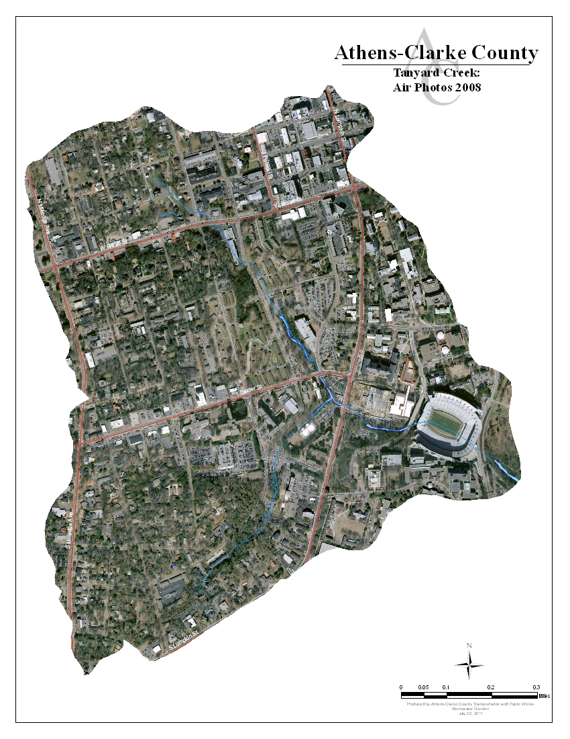 Figure 3.2.4.3 Tanyard Creek: 2008

Agriculture and development affects streams in several ways. First, clear cutting trees to make way for cropland or residential and commercial properties destroyed much of the stream buffers in the Tanyard area. Removal of stream buffers and land clearing can increase runoff and sediment entering the stream systems. The wood debris and leaves produced by trees falls into streams and provides food for macroinvertebrates. As trees disappear so does the primary food source of macroinvertebrates. Agricultural periods can also increase the amount of nutrients present in the stream system. These nutrients can come from fertilizers put on crops that get washed into a stream during a rainstorm, or the nutrients can come from manure, so if livestock are raised on the farmland nutrient s and bacteria may wash into the stream. Finally, sediment may leave agricultural and developed lands via runoff as well. Sediment that enters a waterway may take a long time to move out of the stream since the sediment is suspended in the water when it is stirred up, but settles and deposits at different points in the stream network. This process of transportation and deposition must be repeated many times before the sediment finally makes its way to a larger river. While the historic agriculture is important to note, it is not a likely stressor in TADB due to its early development and increase in impervious area.

The history of stormwater controls also has an impact on the amount of suitable macroinvertebrate habitat found in streams. Prior to the early 1980s, there were no stormwater design requirements for new development projects and in TADB there are few BMPs associated with development due to its development history. This means that stormwater controls like detention ponds, filtration systems, catch basins, and underground piped systems that collect, filter, and slow down runoff were never installed. Runoff leaving sites without stormwater controls often enters streams at a higher velocity and volume that it does when it leaves a site that does employ stormwater controls. The increased velocity can cause stream bank scouring and erosion when the runoff enters a stream, and it also flushes the stream system of suitable habitat as well as macroinvertebrates.

In Tanyard Creek our data tells us that water temperatures are in the normal range, but that buffer damage and sedimentation has reduced macroinvertebrate habitat along several of the reaches. Sampling results also indicate that sediment is sometimes suspended in the water of Tanyard Creek at levels that make it difficult for macroinvertebrates to survive. (See Appendix Section III.1)

While looking at the history of Tanyard Creek is important, we must also look at its future. The Lumpkin Street Rain Gardens, installed in 2006, provide mitigation to both flow and pollutants potentially entering the stream in Reach TA-1C. The University of Georgia’s Facilities Department and Office of University Architects have also expressed great interest in improving the health of the watershed.

3.3 Water Quality Data

3.3.1 Why Sample?

Water quality data are used to characterize waters, identify trends over time, identify emerging problems, determine whether pollution control programs are working, help direct pollution control efforts to where they are most needed, and respond to emergencies such as floods and spills (EPA, Monitoring and Assessing Water Quality). We collected water samples from each of the pilot basins along with a reference watershed, Big Creek. Water quality sample results are compared to a set of water quality benchmarks created by combining both regulatory standards (Georgia Water Quality Standards) and previous research. These benchmarks represent measures of healthy streams. Collecting and testing water quality samples over time gives us a better picture of what pollutants might be traversing our local waterways like Tanyard Creek.

3.3.2 Three Water Quality Sampling Methods

Two sampling methods were used to collect water quality data on Tanyard Creek. First, monthly sampling was conducted at three sampling sites in the watershed. These grab samples cover a wide range of parameters that indicate water quality. We can compare variation in monthly water quality data with stream walks, biological data, and other watershed activities that have happened during the same timeframe to identify potential sources of pollution. The other method we use is in-situ water sampling using data collection units called Datasondes. These data collection units are left in-stream to give us continuous trend-identifying water quality data as indicated by measures of pH, dissolve oxygen, conductivity, turbidity, and temperature. The continuous data is used to identify changes to basic stream chemistry over time and seasonally. The data can also identify significant changes to stream chemistry over time.

Monthly Sampling

Monthly water quality sampling was collected by the grab method, meaning samples were collected from all sample sites at the same time. This method is in compliance with our EPA-approved Quality Assurance Protection Plan (QAPP) that ensures accuracy of results by standardizing our sampling procedures. The criteria sampled were water temperature, pH, dissolved oxygen, conductivity, fecal coliform bacteria, total suspended solids, biochemical oxygen demand, turbidity, total organic carbon, nutrients, and metals. Each criterion is an indicator for a potential type of water pollution. Analysis is conducted by several different labs including the Athens-Clarke County Public Utilities Water Treatment Lab and three University of Georgia Labs: The Center for Applied Isotope Studies; The Soil, Plant, and Water Lab; and the Analytical Chemistry Laboratory. The labs follow methods taken from the Standard Methods for the Examination of Water and Wastewater as developed by the American Public Health Association, the American Water Works Association, and the Water Environment Federation (APHA). Figure 3.3.2.1 includes the water quality sampling sites in Tanyard Creek. Sample data is provided in Appendix Section II.1.

In-Situ Water Sampling Using Datasondes

The Datasonde has multiple probes that sense the following water quality indicators: dissolved oxygen, pH, temperature, conductivity and turbidity. It is able to store these measurements until a staff member retrieves the unit from the stream and downloads the data. Datasondes make it possible for us to collect real-time continuous data without having to be present. The Datasondes are calibrated and checked after each data collection before being returned to the stream. Sample data is provided in Appendix Section II.3.

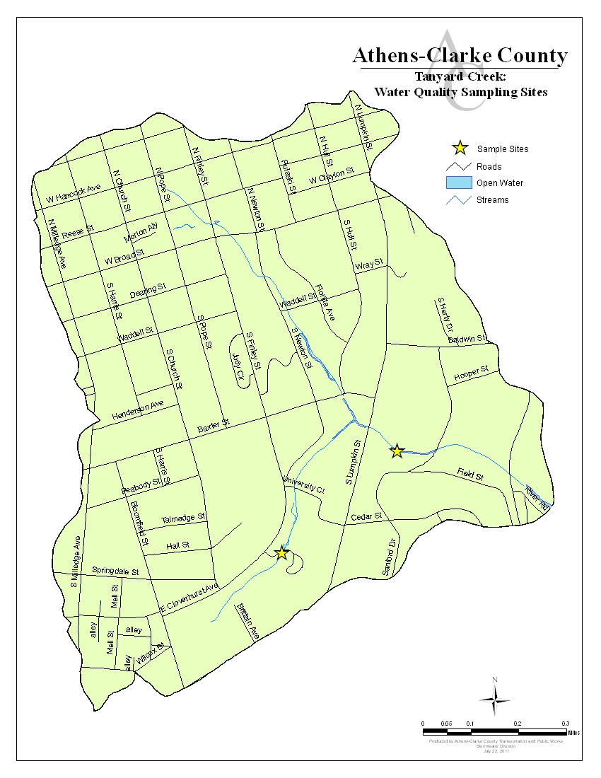
TAN 2
TAN 1
Figure 3.3.2.1: Tanyard Creek Water Quality Sampling Sites

3.3.3 Water Quality Data for Tanyard Creek

Georgia’s water quality standards are set by the State of Georgia Environmental Protection Division (GAEPD). According to the State, the “healthy” range for a number of criteria depends on the designated use of the stream as made by GAEPD. A stream designated for fishing has a higher water quality criterion than one that is just used for outdoor recreation since the fish might be consumed by people. For this project, water quality health is determined using a set of benchmarks defined both by the state water quality standards and previous research. Previous research included a literature review focused on instream, baseflow measurements within the Georgia piedmont. Table 3.3.3.1 shows the benchmarks and monthly averages for all water quality data used in this project, with the bolded benchmarks having regulatory implications. Tanyard Creek is designated as a recreational use stream. Based on available water quality data, the primary constituents of concern related to the benchmarks in Table 3.3.3.1 for Tanyard Creek are Fecal Coliform and Nutrients. To view all sampling results, refer to the charts in Section II.1 in the Appendix where samples scoring outside of the designated “healthy” range are highlighted yellow.

Table 3.3.3.1: Water Quality Benchmarks and Monthly Average Values

Parameter | Benchmark* | TA1 | TA2
Temperature | Para | 16.39 | 15.80
pH | 6.0 to 8.5 | 7.03 | 6.84
Dissolved Oxygen (DO) | > 5 mg/L | 6.65 | 6.46
Conductivity | 0 - 1.5 mS/cm | 0.179 | 0.103
Fecal Coliform | < 500 col | 1043.79 | 1900.38
NO3 | 0.2 – 0.4 mg/L | 2.15 | 0.944
NH4 | 0.01 – 1 mg/L | 0.014 | 0.051
TN | 0.7 – 1.2 mg/L | 2.41 | 1.16
PO4 | 0.002 – 0.1 mg/L | 0.014 | 0.004
TP | 0.06 – 0.24 mg/L | 0.041 | 0.024

Bold = Regulatory standard as defined by Georgia State Water Quality Standards (2009). Non-bold items are parameters that were also measured. Values in exceedance are not a violation of water quality standards, but indicate poor stream health.
*Benchmarks are for streams under normal flow conditions.

3.3.4 Potential Stressors Affecting Tanyard’s Water Quality Scores

If a water quality indicator is not within the acceptable range as designated by GAEPD, this means there has been a standards violation. When it exceeds a benchmark, not a standard, this means the parameter is indicating poor stream health. When we find a violation we look at what might be causing a water quality criterion to be out of range. In Tanyard, several fecal coliform bacteria and nutrient scores were out of acceptable range, but no identifiable trends were noticed.

In our monthly sampling, samples with fecal coliform results exceeding our benchmarks occurred 21 times spread across the two sampling sites. Our data was not always consistent across the watershed and did not indicate any identifiable trends in site TA1, but . The fluctuation across the sampling period does not suggest an ongoing source of fecal coliform contamination at TA1, but may suggest one at site TA2. The dates and fecal counts are in the following tables for each sampling site in Tanyard Creek. Figure 3.3.4.1 contains box plots of all fecal coliform showing that while fecal coliform is a large concern in Tanyard Creek the greatest concern lies at site TA2.

Figure 3.3.4.1: Box Plot of Fecal Coliform Sampling

Fecal coliform can come from leaking septic systems or sewer lines, businesses that have permits to put water back into a stream after an industrial process, and from animal waste. There are several potential, but unverified septic systems in the Tanyard Creek basin, but none within 750 feet of the stream. Instead, the area is served by sewer lines throughout the basin. Between March 2001 and June 2011 there were 10 sewer spills within the Tanyard basin reported by the Athens-Clarke County Public Utilities Department and are highlighted on the map of all spills in Figure 3.3.4.2. None of these spills occurred during the study period. All of these spills were cleaned up and the infrastructure was repaired as necessary.

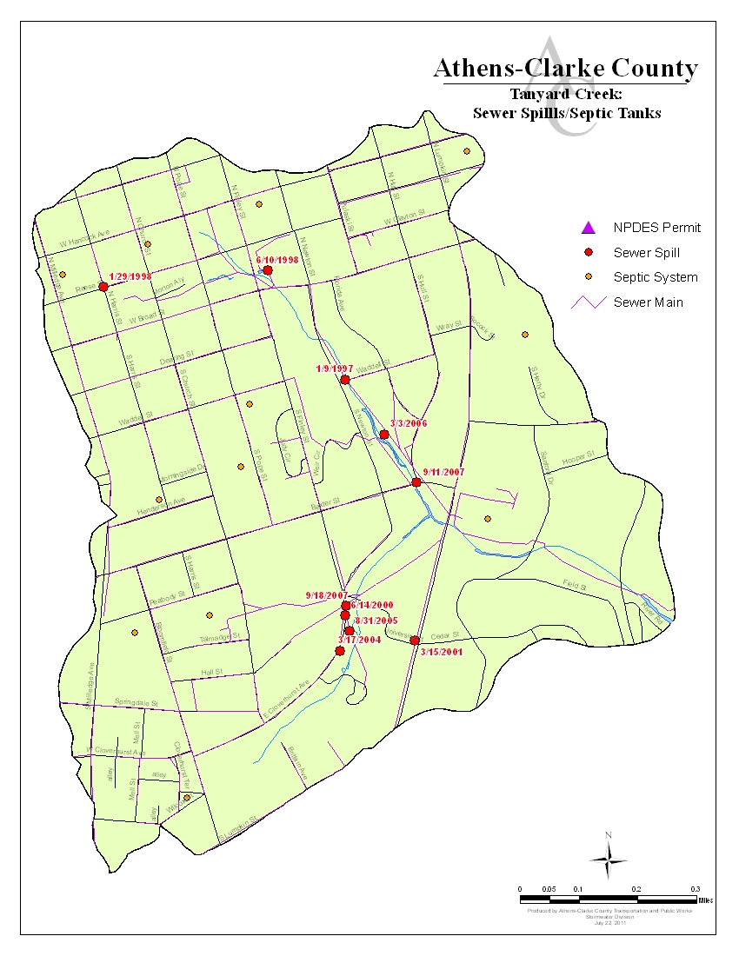
Figure 3.3.4.2 Sewer Spills and Septic Tanks in Tanyard Creek Drainage Basin

During stream walks in the watershed little evidence of wildlife was observed but the presence of squirrels and raccoons were noted throughout the watershed, while evidence of deer was noted in TA-1a. Large concentrations of animal feces near streams can be a source of elevated nutrient levels. Nutrient contributions from these observed species are typically less significant than contribution by waterfowl due to their more terrestrial nature. However, feces deposited on the land surface can result in the introduction of nutrients to streams during runoff events. Given the level of development within the watershed, the buffers along the stream appear to provide the most desirable habitat for wildlife, potentially concentrating wildlife sources of fecal coliform in the stream corridor. We do not have any data on how many domestic pets are in the Tanyard Creek basin. The area surrounding the upstream portions of reach TA-1D and most of TA-1.1 are residential and may house pets, but we do not have enough data to know whether pet waste is a significant contributor to the fecal coliform levels found in the stream.

Nutrient levels are one of the most difficult water quality parameters to calibrate in flowing streams due to differences in local geology, historical land use, stream discharge, and stream size. Increased nutrient concentrations can come from a variety of sources such as: permitted discharges, fertilizers for landscaping and agriculture, and even natural sources such as decomposition of leaf and limb matter. Anthropogenic nutrients in streams can cause algal blooms, which may reduce dissolved oxygen levels and reduce water clarity. Nutrient inputs may also increase the breakdown of leaves and wood in the stream, reducing the amount of food available for macroinvertebrates and fishes. Municipal and industrial entities have permission through NPDES permits to discharge stormwater and treated wastewater into streams. Overland flow of runoff from developed watersheds contains nutrients from lawn and garden fertilizers as well as additional organic debris (leaves and lawn clippings) that are easily washed from urban surfaces. Agricultural areas can also contribute to nutrient increases through poor manure and fertilizing practices and erosion from plowed land. Our observations during stream walks indicate that fertilizes are used in landscaping both on campus and by residents for their lawns. Runoff from permitted discharges and developed land uses can convey increased nutrients found in the stream. As Tanyard is an urban watershed, runoff undoubtedly also contributes to the increased nutrients found in the stream.
In this study, we sampled three forms of nitrogen: nitrate (NO₃), ammonium (NH₄) and total nitrogen. Nitrate and ammonium measure forms of nitrogen that are dissolved in the water column and made available for uptake by biota, while total nitrogen includes both the dissolved ammonium and nitrate as well as organic and particulate forms of nitrogen. Two forms of phosphorus are also sampled in this study: phosphate (PO₄) and total phosphorus. Phosphate is dissolved and inorganic, meaning that it that is easily utilized by plants and microbes. Total phosphorus includes both inorganic PO₄ and organic and particulate forms of phosphorus. In this study, benchmarks for total nitrogen, nitrate, ammonium, total phosphorus and phosphate were set based on scientific literature values (Herhily et al. 2008, Dodds et al. 2002) and baseline data from this study, creating both an upper and lower bound for nutrients (See table 6.1).
All but one sampling event produced a measurement above the benchmarks for nitrate, while no samples were above the benchmarks for ammonia. However, all but four of the total nitrogen samples were above the benchmarks, indicating a significant input of nitrogen into Tanyard Creek. Both phosphate and total phosphorus levels are very low in Tanyard Creek, though. Still, it is important to track inputs of phosphorus; if phosphorus were to be added to these streams and nitrogen remained at moderate levels, it would likely cause significant changes in both algal biomass and organic matter breakdown. Figure 6.5 shows the summary of nutrient samples for Total Nitrogen and Figure 6.6 shows the summary of nutrient samples for Total Phosphorous.

Figure 3.3.4.4 Box Plot of Total Nitrogen

Figure 3.3.4.5: Box Plot of Total Phosphorous

Our observations during stream walks indicate that residents fertilize their lawns and UGA conducts landscaping within the stream buffer. Runoff from permitted discharges and developed land uses can convey increased nutrients found in the stream. As Tanyard is an urban watershed, runoff undoubtedly also contributes to the increased nutrients found in the stream. The impacts of elevated nutrient loading can result in increased algae growth. Excessive growths of attached algae can cause low dissolved oxygen levels, unsightly conditions, odors, and poor habitat conditions for aquatic organisms (WA Department of Ecology, Chapter 3). While increased nutrient levels are not a regulatory violation, they can have regulatory consequences by impacting other water quality parameters.

3.4 Conceptual Model of Tanyard Creek Conditions and Concerns

In order to understand the health of Tanyard Creek watershed, we utilized three main methods of data collection that provide us with information on stream health: conducting a physical stream assessment, collecting biological scores, and collecting water quality data. A conceptual model (Figure 3.4.1) was created to trace these indicators back to their likely sources and identify areas of particular concern in Tanyard Creek. Additional work is needed to identify and locate sources.

Indicators
The three indicators for this study are Water Quality Data, Biological Scores, and Stream Assessment Scores. Water Quality Data come from three sources: monthly grab sampling, datasonde long-term monitoring instruments, and wet weather sampling. This data is then compared to water quality benchmarks created using the Georgia Water Quality Standards and comparable studies of water quality. Biological Scores were obtained by collecting and analyzing macroinvertebrate and algae data. Stream health cannot be solely defined by water quality alone. That is why it is important to conduct physical stream assessments as well. Stream walks were used to gain an understanding of Tanyard Creek’s physical health from the headwaters to the confluence with the North Oconee River.

Impacts

Moving up the model, we looked at the local impacts that lead to the indicators mentioned above. These are the “evidence” that a stream is suffering from some type of water pollution. These indicators include specific impacts with a direct correlation to Water Quality Data like regulatory standards violations and missed benchmarks stemming from algal growth and decreased water quality. Degraded aquatic habitat and impaired aquatic life affect biological scores. In the physical assessment of the stream, we focused on the bed, banks, and buffers and noted the particular impact of deposition, aggradation, and degraded riparian habitat in Tanyard Creek.

Stressors

A variety of more broad stressors cover some of the larger issues of water quality. These stressors include nutrients, pathogens, and chemicals—all important contaminants to be mindful of in stream studies. More importantly in Tanyard Creek, these stressors include Increased Peak Flow and Runoff Volumes, Riparian Disturbance, and Increased Pathogens and Nutrients, which upon analysis are likely the most important contributors to the declining health of the watershed.

Sources/Sub-Sources

Finally, more global sources of stream degradation include Human Activity and other Sources of Water Pollution. In this study of Tanyard Creek, it is evident that a majority of the issues in this watershed stem from human sources, particularly Urban Development and University land uses. Sources of Water Pollution also contribute to poor water quality, but the data does not suggest that the impacts are as great as Human Activity.

Summary

Overall, as mentioned, the driving factor on the condition of TADB is human activity. We can point to three key stressors as having impacts on aquatic life, hydrologic function, and water quality. These stressors are hydromodification due to development, fecal coliform contamination, and excessive nutrients. TADB is probably the most and longest developed watershed in ACC and this has led to increased impervious surface which results in increased storm flows. These increased storm flows have resulted in high flow velocities which “blew out” the stream channel in the upper reaches causing increased sedimentation, incised channels, and channels aggraded with sediment downstream. The combination of sediment and increased flows also decreases the habitat for macroinvertebrates. Fecal coliform contamination has already resulted in the stream being listed on the state’s 303(d) list; however, the sources of this contamination are uncertain at this time and the data shows potential signs of a continuous source, but one has not been identified. Further source identification is needed. The lack of stormwater BMPs noted urban and suburban development are likely the dominant factor in nutrient loading from nonpoint sources in TADB. Also, the lack of vegetated buffers throughout the watershed limits the filtering and treatment of runoff. However, there are methods for controlling some nutrient inputs, such as fertilizers, including education and outreach. Restoration of woody vegetation in riparian buffers may also provide pollutant removal benefits. While this may be nearly impossible in such an urbanized watershed such as Tanyard Creek, other solutions will be needed.

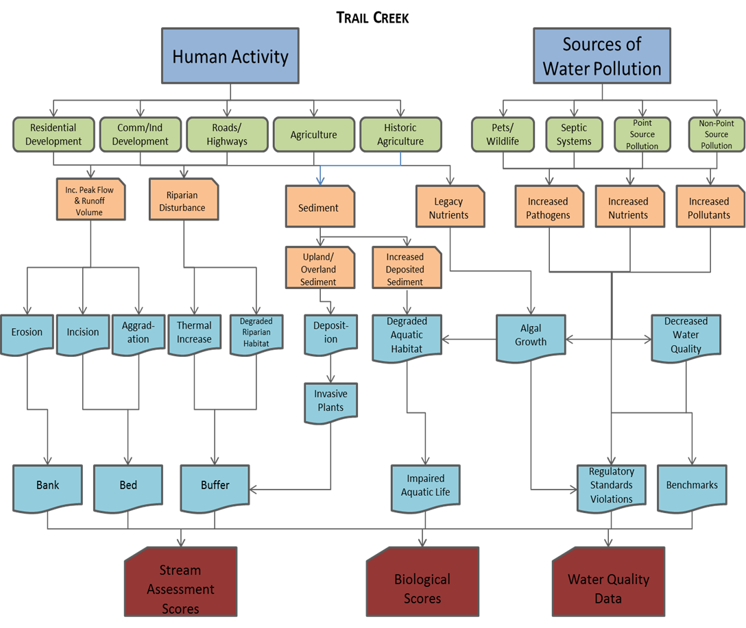

Sources/
Sub-Sources

Stressors

Impacts

Indicators

Figure 3.4.1 Conceptual Model of Human Impacts on Streams

Chapter 4: Identification of Management Needs

4.1 Summary of Management Needs

High levels of imperviousness associated with commercial areas and the University of Georgia campus have caused widespread flow issues, more specifically, high peak flows have degraded streams, caused mass wasting, and are detrimental to a healthy aquatic habitat. The urban-type development has also generated more pollutant loading, elevating levels of nutrients and bacteria in the stream. One of the most important steps in the Tanyard Creek watershed improvement strategy is to use centralized BMPs in existing developed areas to reduce peak flows and pollutant loading. Extended dry detention basins should be prioritized for peak flow reduction and cost in the Tanyard Creek watershed. In the Tanyard Creek watershed, many of the stream channels are piped and/or reinforced along the banks by stone masonry. As a result, the total instream sediment load appears to be low due to limited scour potential. Sections of stream that have not been piped and/or reinforced with bank stabilization measures are good candidates for channel restoration. Natural channel design principles should be used to stabilize banks, create in-stream structures, provide good aquatic habitat, and improve native riparian vegetation. Upstream BMPs that reduce peak flows should be implemented first to promote success of downstream channel restoration efforts. The overall goal of these flow control and restoration efforts is to prevent further degradation of the aquatic habitat and even improve the aquatic habitat in areas where natural channel design restoration measures are implemented. Citizen education efforts should target runoff from lawn and garden areas, as well as pet waste management. Key to this strategy will also be ensuring that new development and redevelopment projects have adequate flow and water quality BMPs through the use of Low Impact Development (LID) requirements. Bacterial source tracking and a sanitary sewer pipeline assessment should be considered when selecting management options to help mitigate elevated fecal coliform levels.

4.2 Best Management Practices to Be Utilized in Tanyard Creek Watershed

4.2.1 Centralized BMPs

These centralized BMPs should target the upstream reaches in order to stabilize flow in the downstream reaches, thus improving the effectiveness of downstream BMPs.

**Extended detention

These devices store stormwater runoff and reduce stormwater peak flow rates. Stormwater enters the device through an inlet, which may be a grass-lined channel or stormwater pipe. An embankment detains stormwater, and an outlet riser controls the downstream release rate of the impounded water. Stormwater is detained for a longer period of time than in conventional dry detention ponds; the longer detention time allows for more removal of Total Suspended Solids (TSS) and nutrients from the stormwater.

4.2.2 Distributed BMPs

Distributed BMPs are smaller BMPs that may be spread throughout the watershed. Implementation of these methods should be considered as a possible part of LID requirements.

Bioretention

Bioretention areas are depressions filled with 2 to 4 feet of sandy soil and planted with drought and flood tolerant plants. Stormwater drains into the surface of the bioretention area and, as the water infiltrates through the sandy soil, the soil and plants remove a portion of pollutants. In areas with sandy loam or other highly permeable soils, the water treated by the bioretention cell will infiltrate into the native soil. In areas that have soils with low permeability (typically clay-dominated soils), a gravel layer and underdrain pipe are placed below the sandy soil layer. Once the stormwater infiltrates through the treatment cell’s sandy soil, it is drained out of the device through the underdrain pipe. Most bioretention areas are designed so that up to a foot of water can pond in the cell during a rain event. A weir is included in the bioretention area to bypass excess water above the ponding depth. Since bioretention areas use mulch and a variety of shrubs and small trees, they can be easily incorporated into existing landscaping.

Rainwater harvesting

Rainwater harvesting reduces runoff during a storm event by retaining a portion of the runoff for future use. This can be accomplished by using storage tanks called cisterns or rain barrels. Cisterns are tanks that hold rainwater for irrigation and other uses. The cistern pictured to the right can hold over 200 cubic feet of water. These BMPs can be pre-manufactured or constructed onsite. They also can be incorporated inconspicuously into the side of a building. Rain barrels typically hold less water than cisterns, about 8 cubic feet per rain barrel. If these devices are designed properly and if water is reused frequently, they can be used to control stormwater runoff, reduce stormwater flow, and remove some pollutants.

Disconnect downspouts

This practice involves reducing the amount of concentrated stormwater runoff leaving a site by disconnecting roof downspouts from drainage systems. Some houses or other buildings may not be directly connected to the municipal storm sewer system, but still may have an onsite drainage system or diffused runoff that could be disconnected. The roof runoff is diffused and directed into natural areas, gardens, bioretention cells, etc.

Retrofit of parking area to disconnect impervious surfaces

This strategy involves the re-design of a parking lot so that runoff is captured and treated in distributed stormwater BMPs like bioretention. Grass swales may be employed as a conveyance to the bioretention, providing additional pollutant removal.

Permeable pavement

Permeable pavement differs from conventional asphalt and concrete in that it allows for infiltration of water during a rainfall event. Permeable pavement types include porous asphalt, porous concrete and paving stones interspersed with sandy soil or other porous fill. These types of pavement vary in vehicular traffic capacity. Grass parking lots, reinforced with plastic rings, are typically used for overflow parking, while some permeable pavement can be designed to handle more frequent traffic.

Swales

A grass swale is a grass-lined channel with sloped banks. Culverts are used to pass stormwater under driveways and streets. Unlike water quality swales, grass swales do not have a sandy soil layer or gravel underdrains. Grass swales are used to convey stormwater runoff and slow stormwater flow. They are an alternative to storm sewer pipes, which produce higher stormwater flows than grass swales, especially for smaller storm events. Grass swales also remove some sediment if the stormwater flow is controlled.

4.2.3 Stream Channel Restoration

Stream channel restoration objectives and practices vary depending on watershed needs, goals, and site constraints. In general, restoration concepts include channel morphology, floodplain structure, hydrologic and hydraulic analysis, in-stream structures, habitats and vegetation, site and watershed conditions, monitoring, maintenance, and education. There are 3 ranked priority levels of restoration. Unfortunately, Priority 1 and 2 stream channel restoration would be difficult in such an urban environment due to lack of space. Priority 3 restorations include the excavation of narrow floodplain benches in confined systems, and they are recommended for Tanyard Creek. Stream channel restoration BMPs should target downstream reaches after flow has been stabilized upstream by centralized BMPs in order to ensure their lifespan and effectiveness.

Instream grade control

Instream grade control is a type of restoration that alters the existing channels and adds structures to the channels that reduce velocity and downstream erosion.

4.2.4 Sewer Line Maintenance/Replacement/Study

This strategy involves replacing or repairing cracks or other sources of leaks in sewer pipes.

Closed Circuit Television (CCTV) study of sewer pipe condition

A CCTV study involves the use of video equipment to evaluate the condition of sewer pipes and identify those that require maintenance or replacement.

Enhanced CIP for sewer pipe maintenance and replacement (potential enhancement of current programs)

A capital improvement plan/program (CIP) includes an enhanced schedule for routine sewer pipe maintenance and replacement of leaking pipes.

Conduct enhanced bacteria study

A field study designed to observe indicators of bacteria loading can help identify the major sources of bacteria in a watershed and lead to more successful management efforts.

4.2.5 Streambank/Riparian Area BMPs

4.2.5.1 Priority Streambank/Riparian Area BMPs

Streambank restoration

Streambank restoration involves the conversion of vertical banks to gradually sloping banks, which are then stabilized and vegetated.

Riparian buffer revegetation
Riparian buffer revegetation, or restoration, involves the re-establishment of natural vegetation along streams where it has previously been removed or destroyed. This activity is usually part of a stream restoration project.

4.2.5.1 Secondary Streambank/Riparian Area BMPs

Streambank stabilization

Streambank stabilization involves adding natural materials or structures to banks to reduce erosion and provide stability. Natural, less structural materials are preferred, but riprap and similar materials may be required along severely unstable reaches.

Riparian buffer preservation (education and conservation easements)

This activity involves preventing the future disturbance of vegetation along streams by purchasing property rights, either through a conservation easement or fee simple purchase.

4.2.6 Citizen Education

Citizen Education Efforts

Citizen education is an extremely important method for improving stream health. Several different methods would be used for educating citizens, as outlined below. Many of these strategies would be utilized county-wide, not just in Tanyard Creek. They are an important part of this WMP however. Each strategy includes:

- Program Description
- Target Audience
- Goals of Program (Broad)
- Expected Outcome (Quantitative)
Stream Clean-Ups
- Residents remove trash and tires from the stream bed, banks, and buffer. Volunteers may also be recruited using Community Connection’s network of volunteers. Partner with the Solid Waste Department in order to have access to roll-off containers for disposal of trash.
- Residents living in the target basin, residents living or owning property near streams.
- To improve stream habitat, connect residents to their local environment, and to gain resident investment in the larger Watershed Improvement Program.
- 500 feet of stream cleaned up and involvement of 15 residents per basin. Also measure the tons of garbage removed from the stream and buffer.
Fertilizer Reduction Program
- Residents are taught how to test the soil to determine how much fertilizers they need. They are taught how and when to fertilize properly, using a fertilizer with nitrogen/phosphorous/potassium ratios recommended by UGA Cooperative Extension Office. Residents can be engaged during the neighborhood meetings but will also be mailed test kits. How many kits are sent in by residents to be tested is a measure of some behavior change. Residents will be asked to create a “no fertilizer and no mowing zone” within x feet from the stream, and the change in buffer width over time can be a measurement of behavior change. The landscaping businesses currently used by basin residents will also be engaged and asked to use only what fertilizers are necessary as prescribed by UGA Cooperative Extension. Residents will be asked to show the soil testing results to their landscapers and request that only the necessary amounts of fertilizers are applied during the appropriate season. Signs may be posted that can be changed to give residents a “green” or a “red” light for fertilizing based on when the next rain event is likely to occur.
- Home owners in target basins, approach by neighborhood or even a collection of streets.
- Overarching goal is to reduce improper fertilizer application and therefore to reduce nutrient levels in the stream. The stream will be sampled before, during, and after the implementation of the program. During the program complimentary media will run on local media outlets.
- Outcomes could include:
  - Enlist at least 50% of households in a residential neighborhood to sign a pledge to eliminate or reduce fertilizer application to once per year. (Follow up periodically to confirm ongoing adoption.)
  - Have 25 residents send in soil testing kits per year.
  - Change in buffer width over time.
  - Fertilizer levels in water before and after program implementation.
Other Desired Behavior Change
- Reduction of soaps and detergents in runoff
  - Give residents car clings that remind them to wash their car on the lawn.
  - Offer coupons for local car washes. Can track how many coupons are redeemed.
- Reduction of pet waste in runoff
  - Give out free doggie bags
  - Have residents and their children do “poop patrol,” putting flags in pet waste left on the ground. Repeat 6 months later and measure the change in the number of flags distributed for the same area.
- Reduction of leaf and lawn litter that enter the stormwater system
  - Leave door hangers explaining the harm done by lawn debris on area houses.
    - Do a visual assessment of lawn debris and leaves in the gutters and stormdrains before and then 6 months after program implementation.
Businesses
- Engage businesses in the Stream Savers Program. This program is still in development but includes business participation in the following types of activities. An “ACC Green Business Award” program might also be effective, and would involve participating in education and behavior change activities designed by ACC Stormwater, Keep Athens-Clarke County Beautiful, ACC Water Conservation, and ACC Recycling.
- Hosting a rain barrel workshop for the general public
- Installing a rain barrel with educational signage on the business property
- Having a “Stream Saver Special” food item or product for sale
- Completing a stormwater audit of the business grounds
- Organizing a team of business employees to take part in a stream clean-up or other environmental service day
- Adopting a stream or highway
- Hosting a visit from the Stormwater mascot, Tortooga
- Completing a water conservation audit
- Watching a stormwater or water quality related DVD during a staff meeting
- Converting to non-toxic cleaners for cleaning the workplace
- Participating in a lunch-n-learn lecture hosted by ACC Stormwater
- Making stormwater education materials available for customers

Complementary Media
Complimentary media campaigns will be run on local media outlets to increase awareness of and advertise for the programs themselves, as well as to educate ACC citizens in general about ways they can protect the health of their watersheds. Advertising for localized neighborhood programs to the larger general audience will help to build awareness of the watershed improvement programs ACC Stormwater will offer and hopefully increase attendance at future public meetings and workshops. Staff should create a media campaign approach that speaks to the interests of the Athens population, but should also draw from resources that already exist from national stormwater pollution reduction campaigns.

4.3 Evaluation and Location of BMP Priority Areas

The BMPs above were further evaluated to select the most promising BMPs for detailed modeling and assessment by individual catchment. Tetra Tech, the environmental consultant used on this project, used available observed and simulated data to designate which catchments presented the greatest management needs, including
- Catchment Loading: estimated total loading from overland runoff in the watershed, including Total Nitrogen (TN); Total Phosphorus (TP); Total Suspended Solids (TSS). These estimates are from the LSPC watershed model results of existing conditions.
- Observed Monitoring Data: measured water quality data including TN, TP, TSS, Dissolved Oxygen (DO), Fecal Coliform (FC), Biological Oxygen Demand (BOD), and Turbidity (as discussed in Section 3.3.3).
- Flashiness Index: a measure of the peak flow of streams. These estimates are from Tetra Tech’s modeling of existing conditions using the project’s LSPC watershed model.
- Aquatic Habitat Score: indicators of overall stream health from the project characterization reports.
- Total Stream Segment Score: an indicator of overall stream condition from the project’s characterization reports.
As noted above, all of the BMPs in the previous section are recommended for the watershed improvement strategy. However, different combinations of BMPs were selected for different catchments. The BMPs were screened for their potential effectiveness and implementation feasibility based on each catchment’s (1) management needs, and (2) existing types and intensities of land cover. Each strategy included a number of distributed and centralized engineering BMPs, streambank and riparian area management, and citizen education. The BMPs selected for more detailed catchment assessment were considered the most promising BMPs; however, other BMPs options on the menu could be effective as well in a given catchment and should also be considered in the future.

Priority reaches for restoration and preservation were selected according to which reaches were rated as moderately degraded during ACC’s field assessment (Section 3.1). Sites were evaluated to ensure that selected reaches exhibited moderate bank erosion, channelization, etc., and selected reaches did not have conditions that would cause major constraints, like unusually high banks or existing structures.
The following table (Table 4.3.1) lists the eight BMP sites that have been chosen as well as the type of BMP recommended at each site. Figure 4.3.1 shows the overall management needs of general regions in the TADB, while Figure 4.3.2 maps out the specific locations of the final selected BMP and stream restoration sites for Tanyard Creek. It should be noted that these BMP IDs are not correlated with the reach IDs used during ACC’s field assessment (Section 3.1).

Table 4.3.1 Planned BMPs for Tanyard Creek

Watershed | BMP ID | Property | Proposed BMP Type
Tanyard Creek | TA-R1 | Public/Private | Stream Restoration/Spot Repairs with Riparian Vegetation Improvements
Tanyard Creek | TA-R2 | Public | Stream Restoration/Spot Repairs with Riparian Vegetation Improvements
Tanyard Creek | TA-R4 | Public | Stream Restoration with Riparian Vegetation Improvements
Tanyard Creek | TA-R6 | Public | Spot Repairs with Riparian Vegetation Improvements
Tanyard Creek | TA-R7 | Public | Stream Restoration with Riparian Vegetation Improvements
Tanyard Creek | TA-D1 | Public | Extended Dry Detention Basin
Tanyard Creek | TA-D2 | Public | Extended Dry Detention Basin
Tanyard Creek | TA-D4 | Public | Extended Dry Detention Basin
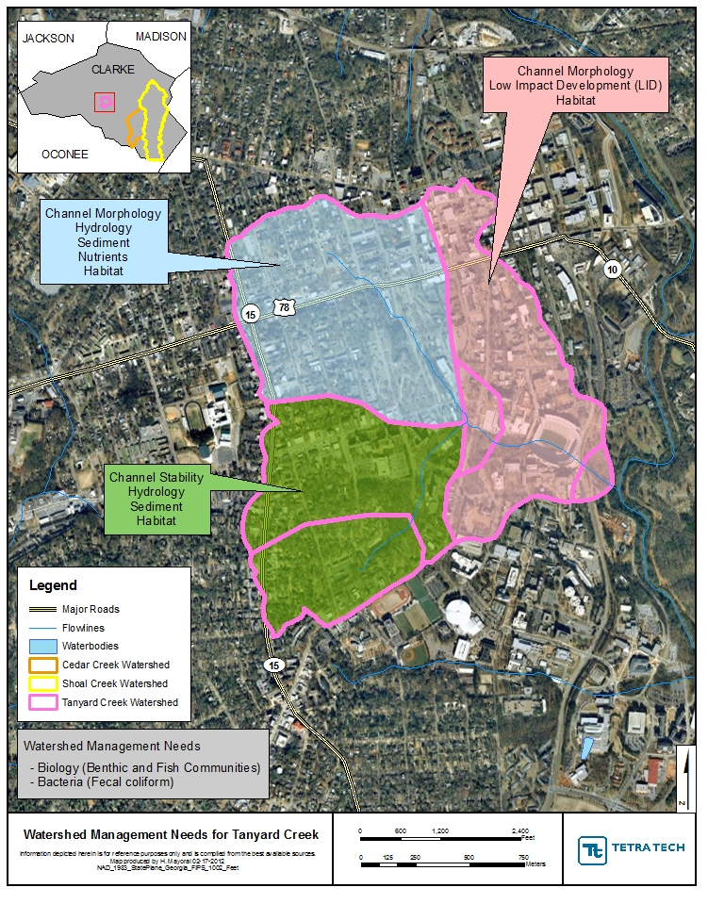

Figure 4.3.1 Tanyard Creek Management Needs and Recommended BMPs

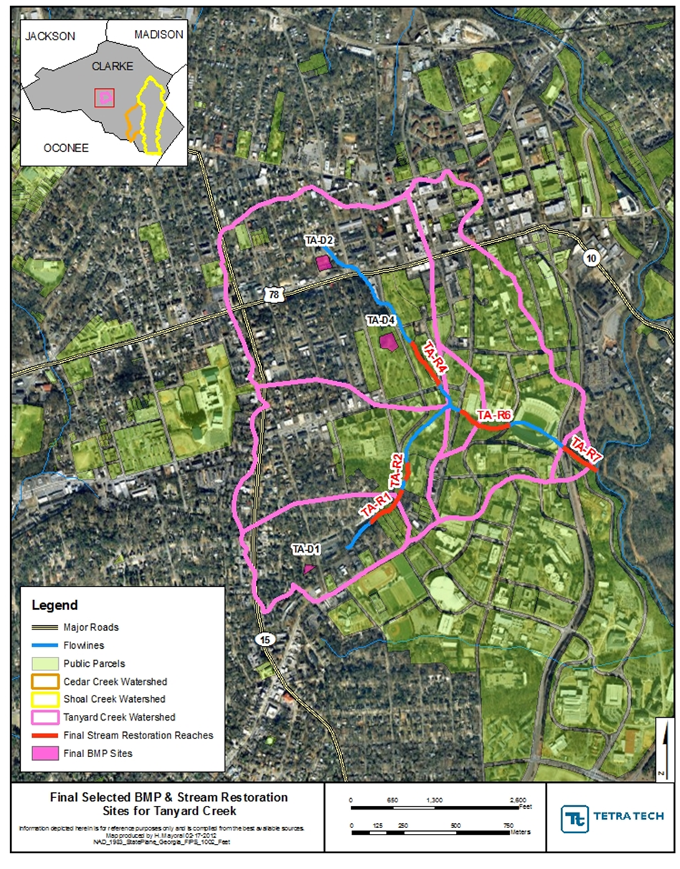

Figure 4.3.2 Final Selected BMP and Stream Restoration sites for Tanyard Creek

4.4 Estimated Load Reductions of Best Management Practices

Modeling analysis was conducted to assess the management needs and BMPs put forth in this plan. In the Tanyard Creek watershed, the strategy employs BMP retrofits upstream of the priority stream restoration reaches in order to address peak flow and volume control impacts. The watershed improvement strategy recognizes that over a number of decades, the other impacted stream sections—on their own—will reach a new, stable equilibrium. Therefore, management resources would not be used to conduct stream restoration except at a limited number of stream sites.
The protection/preservation measures recommended, such as LID for future development projects, were not modeled in the assessment of watershed improvement BMPs since these measures do not address existing impairments. However, these protection measures are critical in maintaining the watershed improvements implemented and in addressing potential future impacts, and thus are included in the watershed management plan.

4.4.1 Characteristics of the Management Plan Strategy

The management plan strategy has a number of key characteristics to achieve:

- 20 percent of the impervious area is managed in the targeted catchment using the centralized and decentralized (engineering) watershed improvement BMPs.
- 75 percent of the residential area is targeted for a homeowner nutrient reduction program.
- 50 percent of the unvegetated stream buffers are restored in the targeted catchments.
- 50 percent of the good candidate streambank/channel restoration or instream grade control sites are implemented.

4.4.2 Modeling and Assessment Approach

Tetra Tech used the Best Management Practices (BMP) Evaluation Module to assess the effectiveness of management measures at the site and catchment level, and to estimate the cumulative effectiveness of the management strategy at the watershed level if implemented. The BMP evaluation module simulates BMP control of flow and water quality. The data inputs for the BMP Module were generated from the watershed model developed for the ACC study watersheds. The model used watershed hydrology and water quality data from the years 1999 to 2008 to estimate the annual pollutant concentration reduction and peak flow control if BMPs are implemented. Tetra Tech also assessed how well the management strategies meet the proposed water quality benchmarks.

Several BMPs were not appropriate to assess in the BMP Evaluation Module: buffer and stream restoration and the homeowner nutrient reduction program. These BMPs were evaluated using the project’s watershed model and Geographic Information System (GIS) coverages of the study watersheds, and then “rolled into” the BMP Evaluation Model results to generate cumulative results for each strategy (except the stream restoration projects, which are reported separately).
4.4.3 Modeling Results

The bar graphs below compare the annual pollutant loading under existing conditions, the moderate and aggressive strategies, and the target pollutant loading needed to achieve water quality benchmarks. As the watershed improvement BMPs are implemented, it will be important to monitor stream conditions to determine how the load reductions achieved affect water quality compared to the water quality benchmarks (to be discussed in Section 4.6).

The watershed improvement strategy in Tanyard Creek uses centralized BMPs (on publically owned parcels) in the most developed, upstream portions of the watershed to decrease high peak flow caused by impervious surfaces and reduce pollutants carried with it. Restoration efforts are then focused downstream where stream banks have not been armored. These BMPs are also designed to halt upstream and downstream flow impacts. Figures 4.4.3.1 through 4.4.3.3 display the predicted reductions in annual concentration for TN, TP, and TSS.

Range of Target Loading
(Not to exceed maximum
of range)

Figure 4.4.3.1 Total Nitrogen Anticipated Concentration Reductions

Water Quality Benchmark
(Not to exceed maximum of range)

Figure 4.4.3.2 Total Phosphorous Anticipated Concentration Reductions

Figure 4.4.3.3 Total Suspended Solids Anticipated Concentration Reductions

4.5 Implementation Cost and Schedule

Implementing this plan will require significant amounts of funding to achieve the load reductions mentioned in the previous section. These reductions will also not occur rapidly and therefore a long-term strategy for both cost and implementation is necessary. Table 4.5.1 provides a 20-year cost estimate for each of the recommended BMP strategies.

Table 4.5.1 Tanyard Creek BMP Costs

Strategy | Land Ownership | Tanyard Creek Planning Level Costs
Strategy | Land Ownership | Land Acquisition | Construction | Design | Annual O&M | 20-Year O&M | Total 20-Year Cost
Citizen Education Efforts | NA | $0 | $0 | $10,000 | $2,000 | $40,000 | $50,000
Enhanced Bacteria Study | NA | $0 | $20,000 | $0 | $0 | $0 | $20,000
Extended Dry Detention Basin | Public | $0 | $356,996 | $107,098 | $4,705 | $94,104 | $558,198
Sewer Pipe Condition Study | NA | $0 | $50,000 | $0 | $15,000 | $300,000 | $350,000
Stream Restoration | Public | $0 | $399,150 | $59,872 | $2,823 | $56,460 | $515,482
Total | NA | $0 | $826,146 | $176,970 | $24,528 | $490,564 | $1,493,680

4.6 Evaluation Methods for Measuring Success

In order to ensure the success of the management measures outlined in this plan, an adaptive management approach is necessary. Continued evaluation, both quantitative and qualitative, will help determine the effectiveness of the variety of BMPs used. All BMPs will be monitored upon implementation, but specific evaluations will take place at 5 year intervals. At this time, if necessary, revisions will be made to this plan in order to improve its effectiveness at enhancing watershed health.

4.6.1 Quantitative Evaluation Techniques

In assessing the current conditions in Tanyard Creek, we have a baseline of data to compare the expected BMPs’ improvements against. In order to assess what improvements have been made, follow-up monitoring and physical assessment will be conducted 5 and 10 years after adoption of this plan. This will include the following activities and goals:

- Streamwalks
  - Activities:
    - Tanyard Creek will again be walked and the same stream reaches will be scored using the same system.
  - Goals:
    - 5-year: 3 of 10 reaches score at least Sub-Optimal (currently 0 of 10)
    - 10-year: 6 of 10 reaches score at least Sub-Optimal, with at least 1 scoring Optimal
- Water Quality Sampling
  - Activities:
    - Quarterly Monitoring: Conduct quarterly grab sampling for parameters of concern including fecal coliform, nutrients (TN, NO₃, NH₄, TP, PO₄), and turbidity (for TSS).
    - Delisting Sampling: Conduct delisting sampling, four samples over a 30-day period, for fecal coliform as described in the Impaired Waters Monitoring Plan.
  - Goals:
    - 5-year: 20 percent reduction in TN and TP, and a 10 percent reduction in TSS
    - 10-year: 40 percent reduction in TN and TP, and a 20 percent reduction in TSS
    - Delisting of Tanyard Creek from the 303(d) list for fecal coliform contamination.
- Biological Monitoring
  - Activities:
    - Macroinvertebrate analysis will be conducted at the current sampling locations and scored using the same system.
  - Goals:
    - 5-year: All sites will improve to a “fair” score.
    - 10-year: All sites will score either “good” or “excellent.”
Other measures will be tracked as well, including the number of BMPs implemented, the amount of impervious surface removed or replaced, the number of cisterns or other rainwater harvesting methods put in place, etc. At 5 years after adoption of this plan, mostly lower cost BMPs such as citizen education and an enhanced bacteria study should be completed, while funding sources are identified for the more expensive BMPs and programs.

4.6.2 Qualitative Evaluation Techniques

A set of qualitative evaluation criteria can be used to determine whether pollutant loading reductions are being achieved over time and whether substantial progress is being made towards attaining water quality standards in the watershed. Conversely, the criteria can be used for determining whether this Watershed Management Plan needs to be revised at a future time in order to meet standards. A summary (Table 4.6.2.1) of the methods provides an indication of how these programs might be measured and monitored to evaluate success in both the short and the long term. By evaluating the effectiveness of these programs, communities and agencies will be better informed about public response and success of the programs, how to improve the programs and which programs to continue. Although these methods of measuring progress are not tied directly to measurements in TanyardCreek, it is fair to assume that the success of these actions and programs, collectively and over time, will impact positively on the instream conditions and measurements of the watershed.

Evaluation Method | Program/Project | What is Measured | Pros and Cons | Implementation
Public Surveys | Public Education or involvement program/project | Awareness; Knowledge; Behaviors; Attitudes; Concerns | Moderate cost.  Low response rate. | Pre- and post- surveys recommended. By mail, telephone, or group setting. Repetition on regular basis can show trends.
Written Evaluations | Public meeting or group education or involvement project | Awareness;  Knowledge | Good response rate. Low cost | Post-event participants complete brief evaluations that ask what was learned, what was missing, what could be done better. Evaluations completed on-site.
Visual Documentation | Structural and vegetative BMP installations, retrofits | Aesthetics. Pre- and post- conditions. | Easy to implement. Low cost. Good, but limited form of communication. | Provides visual evidence. Photographs can be used in public communication materials.
Phone Call/ Complaint records (Stormwater Hotline) | Education efforts, advertising of contact number for complaints/ concerns | Number and types of concerns of public. Location of problem areas. | Subjective information from limited number of people. | Answer phone, letter, emails and track nature of calls and concerns
Participation Tracking | Public involvement and education projects | Number of people participating. Geographic distribution of participants. Amount of waste collected, e.g. stream cleanup waste collection | Low cost. Easy to track and understand. | Track participation by counting people, materials collected and having sign-in/ evaluation sheets.
Focus Groups | Information and education programs | Awareness; Knowledge; Perceptions; Behaviors | Medium to high cost to do well. Instant identification of motivators and barriers to behavior change. | Select random sample of population as participants. 6-8 people per group. Plan questions, facilitate. Record and transcribe discussion.
Adapted from Lower Huron River Watershed Management Plan

Appendix of Charts and Data

Section I – Stream Reach Scores by Parameter
Note: Reaches 1b and 1d were not

Section II – Water Quality Data

II.1 – Monthly Grab Sampling Results

NR = Non-recorded data (due to equipment failure or sampling methods were changed and therefore this data was not recorded)
ND = Non-detectable data (the amount was non-detectable by the sampling method)

Sample Site TA1
Date | Time | Temp (Deg. C) | pH | DO (mg/L) | Conductivity (mS/cm) | Fecal Coliform (#Col/100 mL)
6/22/2010 | 6:55 AM | 22.69 | 9.42 | 5.52 | 0.417 | 1413.6
7/20/2010 | 9:10 AM | 23.31 | 6.8 | 6.4 | 0.205 | 547.5
8/17/2010 | 9:10 AM | 25.63 | 6.64 | 5.01 | 0.09 | 2420
9/14/2010 | 9:20 AM | 20.3 | 6.99 | 4.89 | 0.175 | 980.4
10/12/2010 | 8:40 AM | 19.09 | 6.71 | 5.71 | 0.185 | 307.6
11/9/2010 | 9:00 AM | 13.08 | 7.13 | 6.24 | 0.156 | 261.3
12/7/2010 | 8:49 AM | 8.24 | 6.79 | 8.91 | 0.143 | 920.8
1/4/2011 | 8:35 AM | 8.97 | 6.91 | 8.83 | 0.155 | 325.5
2/1/2011 | 9:00 AM | 10.53 | 6.69 | 6.69 | 0.139 | 2420
3/1/2011 | 8:49 AM | 13.86 | 6.83 | 7.76 | 0.133 | 1413.6
3/29/2011 | 8:35 AM | 12.42 | 6.77 | 8.04 | 0.157 | 648.8
4/26/2011 | 8:45 AM | 18.61 | 6.67 | 5.84 | 0.189 | 866.4
Sample Site TA1 (continued)
Date | NO3-N (ppb) | NH4-N (ppb) | TN (ppb) | PO4-P (ppb) | TP (ppb)
6/22/2010 | 2674.800 | 43.070 | 2901.360 | 30.182 | 39.447
7/20/2010 | 2488.238 | 16.146 | 2747.065 | 29.932 | 43.031
8/17/2010 | 568.991 | 13.798 | 1117.983 | 6.148 | 93.134
9/14/2010 | 2045.724 | 10.152 | 2186.898 | 11.896 | 30.460
10/12/2010 | 2653.213 | 10.599 | 2862.801 | 12.075 | 28.540
11/9/2010 | 2203.503 | 4.403 | 2345.319 | 1.221 | 21.636
12/7/2010 | 2434.802 | 1.345 | 2673.068 | 5.131 | 30.834
1/4/2011 | NR | 3.000 | NR | 0.754 | NR
2/1/2011 | NR | 11.000 | NR | 1.611 | NR
3/1/2011 | NR | 0.000 | NR | 0.845 | NR
3/29/2011 | NR | 1.000 | NR | 0.000 | NR
4/26/2011 | NR | 5.000 | NR | 5.567 | NR

Sample Site TA2
Date | Time | Temp (Deg. C) | pH | DO (mg/L) | Conductivity (mS/cm) | Fecal Coliform (#Col/100 mL)
6/22/2010 | 7:06 AM | 20.93 | 8.73 | 7.31 | 0.305 | 1046.2
7/20/2010 | 9:00 AM | 21.78 | 6.61 | 4.66 | 0.071 | 1203.3
8/17/2010 | 9:20 AM | 25.23 | 6.43 | 5.02 | 0.081 | 2420
9/14/2010 | 9:30 AM | 19.15 | 6.88 | 4.99 | 0.086 | 2420
10/12/2010 | 8:50 AM | 18.25 | 6.68 | 5.2 | 0.088 | 2420
11/9/2010 | 9:10 AM | 13.07 | 6.91 | 6.11 | 0.081 | 2420
12/7/2010 | 8:58 AM | 7.93 | 6.81 | 8.4 | 0.073 | 2420
1/4/2011 | 8:35 AM | 8.89 | 6.88 | 8.05 | 0.076 | 2420
2/1/2011 | 9:10 AM | 10.75 | 6.63 | 6.29 | 0.095 | 648.8
3/1/2011 | 8:56 AM | 13.47 | 6.57 | 6.93 | 0.083 | 980.4
3/29/2011 | 8:40 AM | 12.48 | 6.57 | 8.1 | 0.099 | 1986.3
4/26/2011 | 8:52 AM | 17.67 | 6.41 | 6.49 | 0.093 | 2419.6
Sample Site TA2 (continued)
Date | NO3-N (ppb) | NH4-N (ppb) | TN (ppb) | PO4-P (ppb) | TP (ppb)
6/22/2010 | 1186.900 | 59.003 | 1265.320 | 9.078 | 13.829
7/20/2010 | 930.734 | 38.171 | 1187.009 | 5.453 | 30.398
8/17/2010 | 398.045 | 13.820 | 914.703 | 4.177 | 55.927
9/14/2010 | 1051.362 | 99.064 | 1324.298 | 3.397 | 27.244
10/12/2010 | 1103.499 | 21.504 | 1328.095 | 1.896 | 21.874
11/9/2010 | 869.009 | 4.831 | 924.015 | 0.761 | 8.303
12/7/2010 | 1066.398 | 117.886 | 1206.279 | 1.950 | 12.985
1/4/2011 | NR | 4.000 | NR | 0.065 | NR
2/1/2011 | NR | 13.000 | NR | 1.675 | NR
3/1/2011 | NR | 0.000 | NR | 1.027 | NR
3/29/2011 | NR | 1.000 | NR | 0.026 | NR
4/26/2011 | NR | 5.000 | NR | 0.845 | NR

Grab Sampling Results Graphically Represented by Indicator. Spaces in the data represent either there was no data available or data was below detection limits. Shading is explained below.

= Optimal Benchmark = Level of Concern

II.2 In-Situ Water Sampling Using Datasondes
Gaps in data are due to equipment malfunction and subsequent repair times.

Datasonde Sample Site TA1

Datasonde Sample Site TA2

Section III – Baseline Indicators (as of 2010)

Land Cover Data for Tanyard Creek Drainage Basin
Type of Land Cover | Area (acres) | %
Deciduous Forest | 5.1 | 0.87
Developed, High Intensity | 56.7 | 9.69
Developed, Low Intensity | 281.8 | 48.14
Developed, Medium Intensity | 143.2 | 24.47
Developed, Open Space | 97.4 | 16.64
Herbaceous | 1.1 | 0.19
Total | 585.3 | 100.00

Selected References

American Public Health Association (APHA) , the American Water Works Association (AWWA), and the Water Environment Federation (WEF). Standard Methods for the Examination of Water and Wastewater. http://www.standardmethods.org . December 3, 2009.

Environmental Protection Agency (EPA). Monitoring and Assessing Water Quality. http://www.epa.gov/owow/monitoring. October 20, 2009.

MacTammany, Matthew E. Recovery of Southern Appalachian Streams from Historical Agriculture. Virginia Polytechnic Institute and State University, Blacksburg, VA: 2004.

WA Department of Ecology. A Citizen’s Guide to Understanding and Monitoring Lakes and Streams. http://www.ecy.wa.gov/Programs/wq/plants/management/joysmanual/streamnutrients.html. 2009.

GA DNR/EPD. 2007. Macroinvertebrate Reference Data Piedmont Ecoregion (45), Southern Outer Piedmont -- 45b Data. GA Department of Natural Resources, Environmental Protection Division. Accessed May 2009. http://www.gaepd.org/Documents/WPB_Macroinvertebrate_SOP.html
City of Griffin. 2008. Water quality reference station in Meriwether County; data collected by City of Griffin (2005-2008).
CWP. 2003. Impacts of Impervious Cover on Aquatic Systems. Center for Watershed Protection. Watershed Protection Research Monograph No. 1. Ellicott City, MD.
CWP. 2005. Unified Stream Assessment: A Users Manual. Version 2. Center for Watershed Protection. Urban Subwatershed Restoration Manual Series. Ellicott City, MD.
Fox and Absher. 2002. The ABCs of Water-Quality Assessment in Georgia. Stormwater, March-April 2002. Accessed April 2009. http://www.stormh2o.com/march-april-2002/water-quality-assessment.aspx
GA DNR. 2007. Total Maximum Daily Load Evaluation for Two Stream Segments in the Oconee River Basin for Sediment (Biota Impacted). Submitted to the U.S. Environmental Protection Agency, Region 4, Atlanta, GA. Submitted by the GA Department of Natural Resources Environmental protection Divsions, Atlanta, GA. Accessed March 2009. http://www.gaepd.org/Files_PDF/techguide/wpb/TMDL/Oconee/EPD_Final_Oconee_Sediment_TMDL_2007.pdf
Gore, J.A., J.R. Olsen, D.L. Hughes, and P.M. Brossett. 2005. Reference conditions for wadeable stream in Georgia with a multimetric index for the bioassessment and discrimination of reference and impaired streams. Phase II. Final Report. Columbus State University, Columbus, GA.
Meyer, J. L., M. J. Paul, and W. K. Taulbee. 2005. Stream ecosystem function in urbanizing landscapes. Journal of the North American Benthological Society. Vol. 24(3):602-612.
Paul, M. J., J. L. Meyer, C. A. Couch. 2006. Leaf Breakdown in Streams Differing in Catchment Land Use. Freshwater Biology. Vol. 51:1684-1695. Blackwell Publishing Ltd.
Pitt, R. E. 2000. Water Quality Conditions in the Cahaba River and Likely Pollutant Sources. University of Alabama at Birmingham Department of Civil and Environmental Engineering. Accessed March 2009. http://unix.eng.ua.edu/~rpitt/Publications/MonitoringandStormwater/Cahaba%20problems%20and%20sources.PDF
Roy, A.H., A. D. Rosemond, M. J. Paul, D. S. Leigh, and J. B. Wallace. 2003. Stream Macroinvertebrate Response to Catchment Urbanization. Freshwater Biology 48:329-346. Blackwell Publishing Ltd.
Schoonover, J. E., B. G. Lockaby, S. Pan. 2005. Changes in chemical and physical properties of stream water across and urban-rural gradient in western Georgia. Urban Ecosystems. Vol. 8:107-124. Springer Science + Business Media, Inc.
State of Georgia. 2009. 391-3-6-.03 Water Use Classifications and Water Quality Standards. State of Georgia, Office of the Secretary of State. Accessed March 2009. http://rules.sos.state.ga.us/cgi-bin/page.cgi?g=GEORGIA_DEPARTMENT_OF_NATURAL_RESOURCES/ENVIRONMENTAL_PROTECTION/WATER_QUALITY_CONTROL/index.html&d=1
State of Georgia. 2009. 391-3-6-.03 Water Use Classifications and Water Quality Standards. State of Georgia, Office of the Secretary of State. Accessed March 2009. http://rules.sos.state.ga.us/cgi-bin/page.cgi?g=GEORGIA_DEPARTMENT_OF_NATURAL_RESOURCES/ENVIRONMENTAL_PROTECTION/WATER_QUALITY_CONTROL/index.html&d=1
Tetra Tech. 2006. Baseline Biological and Water Quality Conditions for Selected Streams in Dekalb and Fulton Counties, Georgia. Prepared by Tetra Tech, Inc. Prepared for US Army Corps of Engineers, Mobile District.
USEPA. 2000. Ambient Water Quality Criteria Recommendations: Rivers and Streams in Nutrient Ecoregion IX. US Environmental Protection Agency, Office of Water. EPA 822-B-00-019. Accessed April 2009. http://www.epa.gov/waterscience/criteria/nutrient/ecoregions/rivers/rivers_9.pdf

